

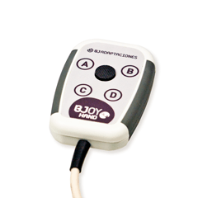

|  |  |  |
| --- | --- | --- |
| **Access Training Day**  *23rd January 2018*  *9.30am – 1:00pm*  Bristol Communication Aid Service  Claremont Primary School  Henleaze Park  Westbury-on-Trym  Henleaze, Bristol  BS9 4LR |  |  |
|  |  |



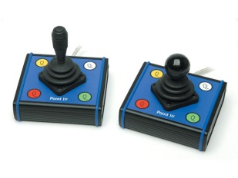

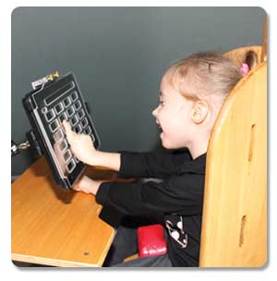

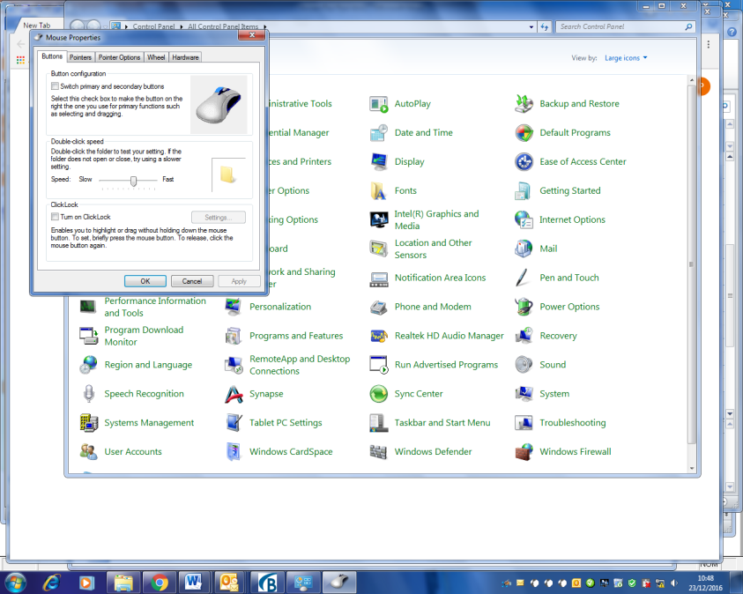

**What is the training?**

A half-day of free training looking at different access methods, focusing on direct access and accommodating changes in upper limb physical function.

This training is aimed at Speech and Language Therapists, Occupational Therapists, Teachers, Teaching Assistants, Support workers and other professionals working with people who do, or could, use AAC.

**What happens on the day?**

A half-day of practical training focused on how to facilitate service users to maintain effective direct access methods and use of simple indirect access accessories. An overview will also be given into the range of indirect access methods.

P*lease note that drinks and biscuits will be available throughout the day, but lunch will not be provided.*

**Learning outcomes**

Attendees will gain a better understanding of:

* Upper limb function
* The effect of posture and positioning on function
* Different solutions for promoting and maintaining direct access
* How to adjust computer settings to facilitate direct access
* The range of stylus, joystick and mice available
* Alternative methods of indirect access

The course leaders are keen that attendees learn from each other’s knowledge and experience, and go away with some practical ideas for the AAC users they work with.

**Book a place on the course:**

If you wish to register please contact The Bristol Communication Aid Service on **0117 4145850** or email [cacadmin@nbt.nhs.uk](mailto:cacadmin@nbt.nhs.uk) First come, first serve basis, places are limited. Please book soon to avoid disappointment