My way forward
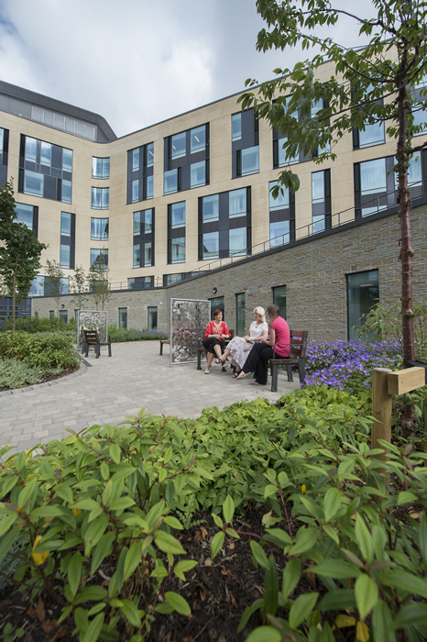

Name of carer or next of kin:

Date of discharge from Hospital:

Name of Keyworker:
Contact Number:

When you go home, here are helpful numbers if:
You have a general concern:
Contact details or advice line number
You have a question about your medication:
Pharmacy Helpline
You have a non-urgent medical problem:
Dial 111 and GP contact details
You have an urgent medical problem:
Dial 999
‘If you are in another hospital or rehabilitation centre please discuss any concerns with the staff there in the first instance. But you’re welcome to contact your key worker on the number above’
Exceptional healthcare, personally delivered
Details of your diagnosis and treatment
Date of diagnosis:
Date of admission to hospital:
Why you were admitted:
Condition | Management | Consultant and Speciality

What you and your carer/family should look out for:

If you are concerned, please call..

Contacts after discharge from hospital

What hospital appointments should you expect after discharge?

If you don’t receive information about these expected appointments, please call xxxxx (appointments line number)

Information about your rehabilitation
At the moment, these are your abilities: for example
- You can walk short distances with crutches, putting only partial weight through your left leg
- You are unable to climb stairs
- You need help to get washed and dressed
- You can only eat soft-textured foods
You should expect the physiotherapist in the community to come and see you. They can be contacted on this number: XXXXXXX

Your hospital therapists have discussed the following goals with you: for example
- Starting to walk independently with elbow crutches
- Maintaining the range of movement in your injured joint using the exercises below
The community team will help you with this.

You have been given these activities to do: for example
- Bed exercises
- Gradually increasing the distance you can walk

[Specific documents can be downloaded or attached to suit the patient’s need]

