Definitions of Mindfulness
Mindfulness means awareness arising from
paying attention in a particular way:
On purpose,
In the present moment,
Without judgement, Without reaction.
Jon Kabat-Zinn (JKZ)

The essence of mindfulness is to be fully aware of our experience in each moment, equally open to whatever it has to offer and free of the domination of habitual, automatic, cognitive routines that are often goal-oriented and, in one form or another, related to wanting things to be other than they are.
John Teasdale

Mindfulness is a mental training based on Buddhist practices. It involves getting to know the habits of the mind. It’s about being more in the present moment and noticing that the mind has a tendency to get hijacked, either by the past with regrets or by the future with worries and concerns.
Mark Williams

Consciously bringing awareness to your here-and-now experience with openness, interest and receptiveness.’
Russ Harris

Kindness
The awareness we are cultivating is wise and kind.
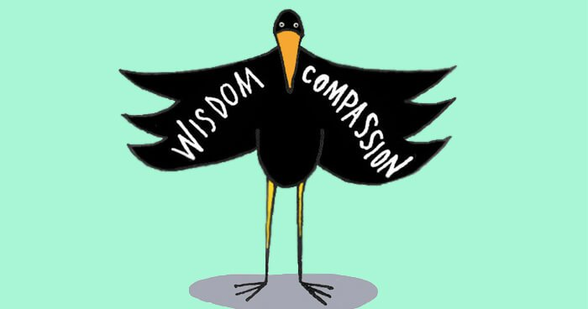

Summary of Session 1 – Automatic Pilot
In a car we can sometimes drive for miles "on automatic pilot", without really being aware of what we are doing. In the same way, we may not be really "present", moment by moment, for much of our lives: we can often be "miles away" without knowing it.
On automatic pilot, we are more likely to have our "buttons pressed". Events around us, and thoughts, feelings and sensations (of which we may be only dimly aware) can trigger old habits of thinking and reacting that can be unhelpful, and may lead on to a worsening of our mood or physical state.
By becoming more aware of our thoughts, feelings and bodily sensations from moment to moment, we give ourselves the possibility of greater freedom and choice. We do not have to stay in the same old ruts that may have caused problems in the past and still be causing difficulties.
The aim of this course is to increase our awareness so that we can respond to situations with choice, rather than reacting automatically. We will practise becoming more aware of where our attention is, and deliberately changing the focus of attention, over and over again.
To begin with, we use attention on different parts of the body as a focus to anchor our awareness in the present moment. We will also be training ourselves to put attention and awareness in different places at will. This is the aim of the Body Scan exercise, which forms the main homework exercise this week.
“Now, what are we going to do?”
When we are not in the moment, we miss opportunities to discover what works
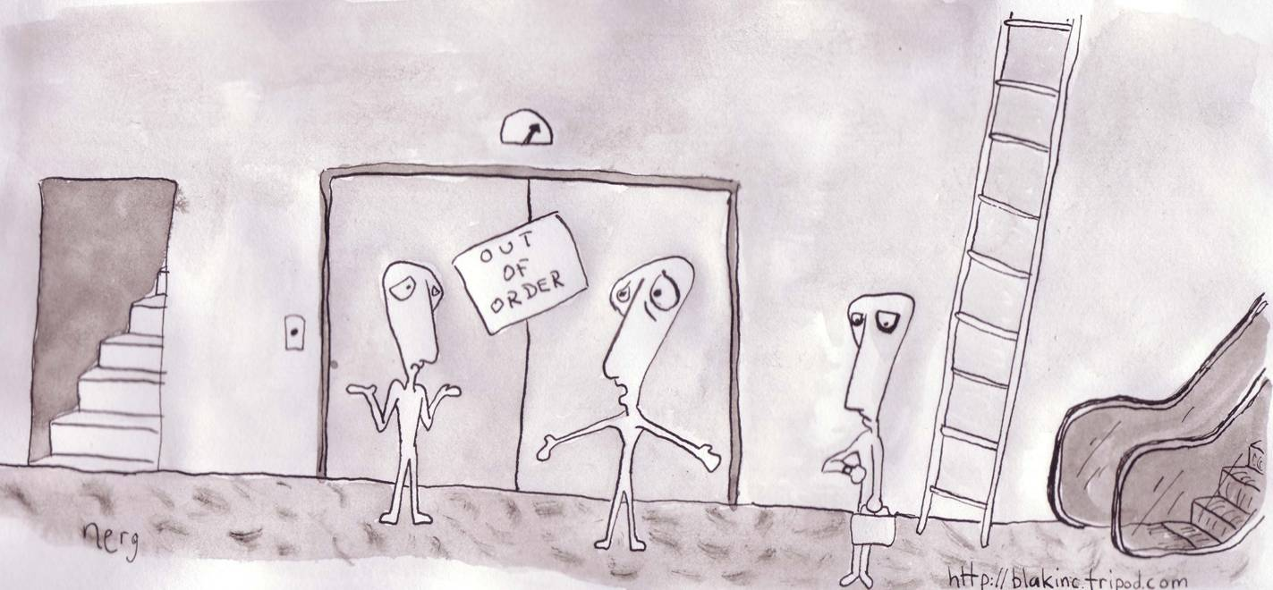

Patient experiences
These are comments from some patients who have undertaken mindfulness training, looking back after 8 weeks.
- I had heard about mindfulness before I started the eight week course but I didn't really know what it was about. After the first two sessions I was feeling very bored with body scans and finding it really difficult to concentrate on the exercises. I kept beating myself up because my mind kept wandering off or sometimes I even fell asleep.
- Eventually, I just put the recording on and expected to go off into a realm of thoughts; I didn’t worry if concerns came in. Gradually, the flights of fantasy reduced, I was happy to listen to him, and then I started to get some value from it.
- Soon I had developed it so that I could actually feel the breath going down to the base of my foot. Sometimes I didn’t feel anything but then I thought, ‘If there’s no feeling then I can be satisfied with the fact there is no feeling.’
- Being aware of what was happening in the here and now. It was not about being perfect, or doing better than the day before, whatever that meant. Now when my thoughts do drift off, either thinking about the past or planning for the future, I just gently come back to focus on my breathing. No recriminations, no sense of "not doing it properly". I know now that I am being mindful.
- It’s not something you can do half a dozen times. It’s got to be a daily thing. It becomes more real the more that you try it. I began to look forward to it.
- If people have got to structure the time for the 45 minutes for the practice, it may be easier to structure other things in their life as well. The recording, in itself, would prove an impetus.”

Body Scan Meditation
- Lie down, making yourself comfortable, lying on your back on a mat or rug, on the floor or on your bed, in a place where you will be warm and undisturbed. Allow your eyes to close gently.
- Take a few moments to get in touch with the movement of your breath and the sensations in the body. When you are ready, bring your awareness to the physical sensations in your body, especially to the sensations of touch or pressure where your body makes contact with the floor or bed. On each out-breath, allow yourself to let go, to sink a little deeper into the mat or bed.
- Remind yourself of the intention of this practice. Its aim is not to feel any different, relaxed, or calm; this may happen or it may not. Instead, the intention of the practice is, as best you can, to bring awareness to any sensations you detect, as you focus your attention on each part of the body in turn.
- Now bring your awareness to the physical sensations in the lower abdomen, becoming aware of the changing patterns of sensations in the abdominal wall as you breathe in, and as you breathe out. Take a few minutes to feel the sensations as you breathe in and as you breathe out.
- Having connected with the sensations in the abdomen, bring the focus or “spotlight” of your awareness down the left leg, into the left foot, and out to the toes of the left foot. Focus on each of the toes of the left foot in turn, bringing a gentle curiosity to investigate the quality of the sensations you find, perhaps noticing the sense of contact between the toes, a sense of tingling, warmth, or no particular sensation.
- When you are ready, on an in-breath, feel or imagine the breath entering the lungs, and then passing down into the abdomen, into the left leg, the left foot, and out to the toes of the left foot. Then, on the out-breath, feel or imagine the breath coming all the way back up, out of the foot, into the leg, up through the abdomen, chest, and out through the nose. As best you can, continue this for a few breaths, breathing down into the toes, and back out from the toes. It may be difficult to get the hang of this – just practice this “breathing into” as best you can, approaching it playfully.
- Now, when you are ready, on an out-breath, let go of awareness of the toes, and bring your awareness to the sensations on the bottom of your left foot – bringing a gentle, investigative awareness to the sole of the foot, the instep, the heel (noticing, for example, the sensations where the heel makes contact with the mat or bed). Experiment with “breathing with” the sensations – being aware of the breath in the background, as, in the foreground, you explore the sensations of the lower foot.
- Now allow the awareness to expand into the rest of the foot – to the ankle, the top of the foot, and right into the bones and joints. Then, taking a slightly deeper breath, directing it down into the whole of the left foot and, as the breath lets go on the out-breath, let go of the left foot completely, allowing the focus of awareness to move into the lower left leg – the calf, shin, knee, etc., in turn.
- Continue to bring awareness, and a gentle curiosity, to the physical sensations in each part of the rest of the body in turn – to the upper left leg, the right toes, right foot, right leg, pelvic area, back, abdomen, chest, fingers, hands, arms, shoulders, neck, head and face. In each area, as best you can, bring the same detailed level of awareness and gentle curiosity to the bodily sensations present. As you leave each major area, “breathe in” to it on the in-breath, and let go of that region on the out-breath.
- When you become aware of tension, or of other intense sensations in a particular part of the body, you can “breathe in” to them – using the in-breath to gently bring awareness right into the sensations, and, as best you can, have a sense of their letting go, or releasing, on the out-breath.
- The mind will inevitably wander away from the breath and the body from time to time. That is entirely normal. It is what minds do. When you notice it, gently acknowledge it, noticing where the mind has gone off to, and then gently return your attention to the part of the body you intended to focus on.
- After you have “scanned” the whole body in this way, spend a few minutes being aware of a sense of the body as a whole, and of the breath flowing freely in and out of the body.
- If you find yourself falling asleep, you might find it helpful to prop your head up with a pillow, open your eyes, or do the practice sitting up rather than lying down.

