Session 1

Practice to do at home:
- Body scans
15 minutes
https://soundcloud.com/fiona-mckechnie108681984/15-min-body-scan-fiona-wright/s-OcfX3
30 minutes
https://soundcloud.com/fiona-mckechnie108681984/half-hour-body-scan-fiona-wright/s-1NJPz
- Awareness of routine activity
- Reflective log

Body Scan
Over the next fortnight, aim to do the Body Scan practice six days a week. Ideally try to do the 30 minute one, but if that’s not possible every day then do the 15 minute one.
The body scan provides a direct way to connect with awareness of the body. The body is a place where emotions are often expressed, under the surface and without our awareness. So being aware of the body gives us another place to stand and view our preoccupations and concerns. It can also be an opportunity to develop some friendliness towards and trust in your body, particularly if you feel it has let you down.
Don't expect to feel anything in particular from listening to the recording. In fact, give up all expectations about it. As best you can, just let your experience be your experience, whatever it is. Don't judge it, just keep doing the practice, and we'll talk about it next time we meet.

Posture for the body scan
This is typically done in lying, but can be done in sitting.
Spending time setting up is as much a part of the practice as “doing it”. In lying you want to be on a comfortable surface, a mat, rug etc think carefully about a bed as you might find, it too comfortable, but on the other hand, it might be the best place for you. You can lie on your back, front or side. Use cushions to prop yourself ; if you need to shift position, do this with awareness. Your temperature might drop so use a blanket or have one to hand. These are all lying positions you can use for mindfulness practice
see this for more ideas for using cushions, blankets and bolsters: https://www.access2yoga.com/wp-content/uploads/2014/10/Adaptive-Yoga-Manual.pdf
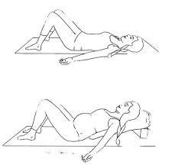
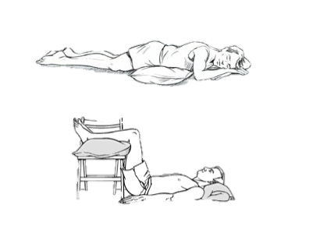
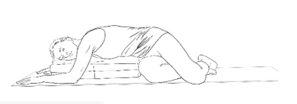
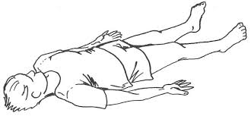

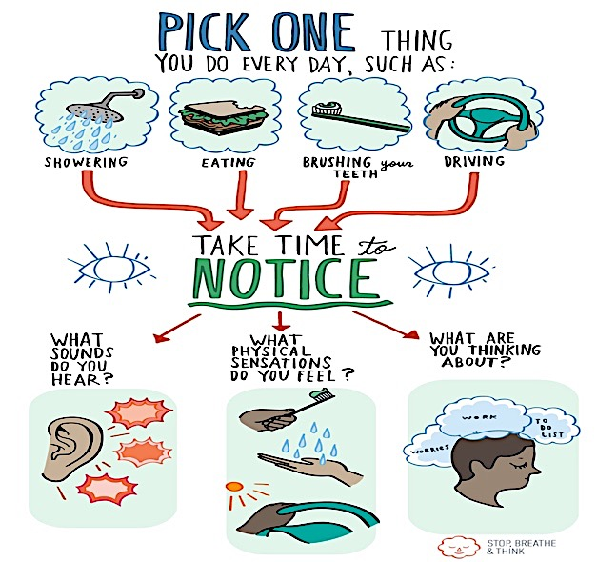
Awareness of a Routine Activity

Make a note of your experience here.
Activity | Reflection

Reflections
You may find it helpful to make a note of what happens in the sessions and also when you try things at home.

Reflections after the session

Experience of following the guided practice at home (e.g. which practice, how long, what did you notice)

Thoughts about mindful activity

Anything else

Additional Resources

A chocolate meditation!
http://cdn.franticworld.com/wp-content/uploads/2012/02/Chocolate-Meditation-from-book-Mindfulness-Finding-Peace-in-a-Frantic-World-128k.mp3

YouTube clip (4 mins)
https://www.youtube.com/watch?v=iS53roI_pWE&list=PLbiVpU59JkVbFtkacXoByNjHJgGc4AryM&index=3

