Session 2 - Coming to the body
Our aim in this course is to be more aware more often so we can sometimes respond wisely rather than react automatically.

A judging mind – it’s not quite right, I need to do better…
A powerful influence that can take us away is our automatic tendency to judge our experience as being not quite right in some way – that is, it is not what should be happening, not good enough, or not what we expected or wanted. These judgements can lead to sequences of thoughts about blame, what needs to be changed, or how things could or should be different. Often, these thoughts will take us, quite automatically, down some fairly well worn paths in our minds and may intensify any difficult feelings (frustration or loss) that may be present.
In this way we may lose awareness of the moment, and also lose the freedom to choose what, if any, action needs to be taken.

Regaining freedom
By acknowledging the actuality of the situation we find ourselves in, without being immediately hooked into automatic tendencies to judge, fix, or want things to be other than they are.

When we stop trying to force pleasant feelings,
they are freer to emerge on their own.

When we stop trying to resist unpleasant feelings,
we may find that they can drift away by themselves.

When we stop trying to make something happen,
a whole world of fresh and unexpected experiences
may become accessible to us.

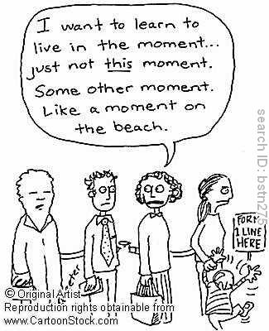

Practising being in the moment with the body scan
The only discipline involved is regular and frequent practice.
The body scan exercise provides an opportunity to practise bringing, as best you can, an interested and friendly awareness to the way things are in each moment, without having to do anything to change things. There is no goal to be achieved, other than to bring awareness to bear as the instructions suggest specifically, achieving some special state of relaxation is not a goal to aim for in the exercise.
- Regardless of what happens, “just do it!” (e.g. if you fall asleep, lose concentration, keep thinking of other things, keep focusing on the wrong bit of body, not feeling anything). These are your experiences in the moment, just be aware of them.
- If your mind is wandering a lot, simply note the thoughts (as passing events) and then bring the mind gently back to the Body Scan.
- Let go of ideas of "success", "failure", "doing it really well", or "trying to purify the body". This is not a competition. It is not a skill you need to strive for. Just do it with an attitude of openness and curiosity.
- Let go of any expectations about what the Body Scan will do for you: Imagine it as a seed you have planted. The more you poke around and interfere, the less it will be able to develop. So with the Body Scan, just give it the right conditions peace and quiet, regular and frequent practice that is all. The more you try and influence what it will do for you, the less it will do.
- Try approaching your experience in each moment with the attitude: "OK, that's just the way things are right now". If you try to fight off unpleasant thoughts, feelings, or body sensations, they will only distract you from doing anything else. Be aware, be non-striving, be in the moment.
Accept things as they are, just do it.

Anchoring practice
Settle into a comfortable position, either sitting, standing or lying (see the videos and other notes for sitting and lying positions).
Let your weight drop and feel the support of the chair, floor etc, notice if there is any additional holding or tensing you can perhaps release, make yourself 10% more comfortable.
Allow the spine to adopt an erect or elongated and comfortable posture. If sitting on a chair, have the feet flat on the floor with the legs uncrossed. If it feels OK, gently close the eyes.
Bring your awareness to the level of physical sensations by focusing your attention on the sensations of touch, contact, and pressure in your body where it makes contact with the floor and with whatever you are sitting on. Spend a minute or two exploring these sensations, just as in the body scan.

Choose an anchor- where do I feel connected, secure, perhaps calm?
Bring your attention there, gently and lightly,
Let your mind wander, notice then then gently return to the anchor. Notice how you feel when you return.
Stay with this for a few minutes, letting the mind wander then returning to the anchor.
Gentle, friendly, curious
Practice a few times a day.

Places to anchor
Sounds
Vision
Feel your feet
Feel your hands
Contact with surface you are sitting, standing or lying on
Breath moving the body
Footsteps (if walking)
Open and closing hands
Counting 1-2-3
Others?

The Breath
Breathing is often used as an anchor and as a way of being in touch with how we are feeling.
Breath is life. You could think of the breath as being like a thread or a chain that links and connects all the events of your life from birth, the beginning, to death, the end. The breath is always there every moment, moving by itself like a river.
Karen Ryder
Breathing is a physiological process that happens without us having to think about it, however It's an interesting process as we can control it too. Breathing is constantly changing, it responds to how we are feeling, when we are tense anxious, worried or angry the breath can become short shallow and fast. When we are relaxed and happy it can be slow and deep and gentle. You may also notice if you put a lot of effort into something, you are perhaps holding your breath.
Babies and animals breathe with their whole body every part moves with the breath. As we develop and create patterns of activity and habitual reactions we may find that our breath is more constricted and that we do not feel it throughout our bodies.

Using the breath as a support
By noticing our patterns of breathing we can consciously use our breath to soothe ourselves. However, this can be challenging so we suggest that at first we observe our breath particularly when we are feeling relaxed happy and content, starting to inquire and to how the body feels when we are aware of pleasure. You may notice your breath drop slow and the exhale lengthen when you appreciate for example a beautiful tree or flower.
By paying attention in this way to the body breathing we are developing a resource we can use at times of need. For example if we notice we're feeling distressed or anxious we might notice that our breathing is very tight and if we've been practising observing and being with our relaxed breath we can use this resource to consciously breathe in a way that supports us.

Remember if you are breathing there is more right with you than wrong with you!

And…. there is no correct way to breathe, you are breathing that is enough.

Mindfulness of the Breath
Settle into a comfortable position, either sitting, standing or lying (see the videos and other notes for sitting and lying positions).
Let your weight drop and feel the support of the chair, floor etc., notice if there is any additional holding or tensing you can perhaps release. Make yourself 10% more comfortable.
Allow the spine to adopt an erect or elongated and comfortable posture. If sitting on a chair, have the feet flat on the floor with the legs uncrossed.
If it feels OK, gently close the eyes.
Bring your awareness to physical sensations by focusing your attention on the sensations of touch, contact, and pressure in your body where it makes contact with the floor and with whatever you are sitting on. Spend a minute or two exploring these sensations, just as in the body scan.
Now bring your awareness to the Movement that is occurring in the body, and if it feels ok, ask yourself some of the following questions, notice any judgements or expectations that arise and come back to gentle curiosity:
- where do I feel the breath?
- where is the movement most noticeable? In the lower or the upper part of the body?
- Where does the movement of the breath begin?
- Frequency of the breath, is it fast or slow? Does this vary?
- Is there a difference between the length of inhalation and exhalation?
- Is the breath smooth and even or is it jerky or perhaps ragged?
- How deep is the breath? deep or shallow? (Remember there is no right way to breathe you are still breathing!)
- If you could describe the breath, what kind of breath is it? do any images come to mind?
Spend some time being with your breath, being with the body moving, allowing the body to move if it needs to, being curious about the movements and sensations. If you notice any tension arising then gently bring some attention to this and then let your mind come back to the breath.
When your mind wanders, allow it, then gently redirect your attention when you're ready.
Bring a quality of kindness and gentleness to your awareness, remember again there is no right way to breathe you are breathing!

What we think we are doing when we practice mindfulness

Attention to the track
Guidance track

What we actually do when we practice Mindfulness

Attention to the track wanders…

Guidance track

Good news is Mindfulness is noticing that the mind is wandering all over the place, falling asleep etc.
Attention to the track wanders…

Moments of awareness and choice

Guidance track

“It wasn't till after the third session that I really understood what being non-judgmental and gentle with myself meant. It didn't matter that my thoughts drifted off during the exercises. All I needed to do what to be aware that they had and gently bring myself back to focussing on my breathing. That was what being mindful was about.”

Mindfulness and The Window of Tolerance
Mindfulness can be helpful, sometimes though we can become very aware of how we are feeling and this can be uncomfortable. If this happens don’t worry, but do get in touch if you need to in between sessions.
The following might be helpful and there are some practical things you can do to support yourself.
The “Window of Tolerance is the optimal zone of arousal where we are able to manage and thrive in everyday life. This can be thought of as sailing within a river of well-being where we are able to respond to all that comes our way without getting thrown off course. When we are outside of our window of tolerance, our nervous system responds by going into survival mode – fight, flight or freeze. We can either feel overwhelmed and go into hyper-arousal or we can shut down and go into hypo-arousal. Our window of tolerance can be narrow or wide and is different for all people and at different times in our lives.
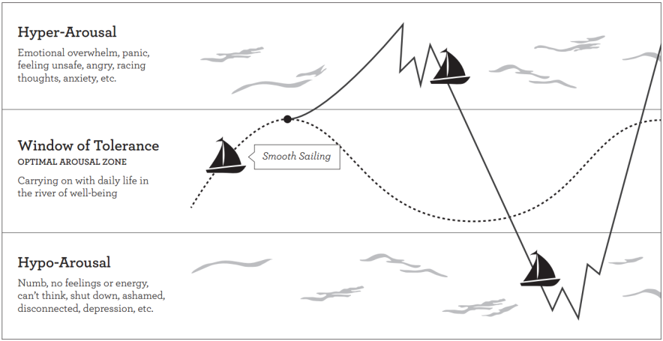

When we are able to widen our window of tolerance, we can enjoy more smooth sailing regardless of the waves, obstacles and adventures we encounter. Emotion regulation depends on our ability to be mindful of fluctuations in our level of arousal and to respond wisely. By becoming aware of body sensations, thoughts and emotions, we can learn to recognize when we are in our optimal zone of arousal or going into hyper or hypo-arousal.

Mindfulness gives us skills to:
- Enjoy when we our sailing within our river of well-being
- Notice when we are heading into rough waters and steer us back on course
- Recognize when were in the danger zone and bring ourselves back to safety through grounding skills

Grounding Skills
Grounding skills can serve as a life preserver in those moments of extreme distress- here are some examples:
- Take deep breaths; extend your
- Release gripped hands
- Stand tall; feel the ground beneath you
- Take a brief walk
- Notice your feet connecting with the floor
- Orient to and label objects in the room
- Listen to a song you enjoy
- Call a friend you trust
- Remember Harry Potter used small squares of chocolate recovering from a dementor attack!

If you are “spacing out” need to increase your alertness you can ground yourself then try
- Focussing on 2-3 in- breaths
- Rising up though your spine and head
- Rapid movement- eg shaking hands
- Raising your gaze- eg looking at the horizon between the wall and the ceiling; tops of trees etc

How do I know I’m sailing out of the window of tolerance?

Things I’m going to try to ground myself

