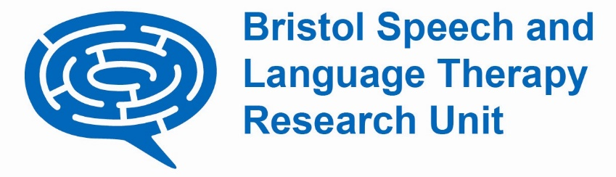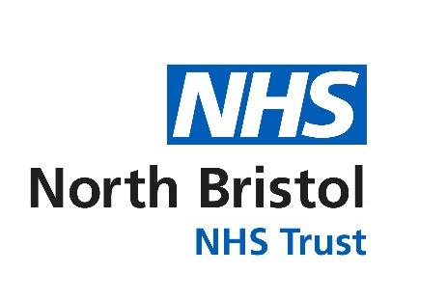

**Annual Report**

**April 2023 – July 2024**A group of people posing for a photo



*From left*: Yvonne Wren, Caitlin Holme, Rhonwen Lewis, Charlotte McCarthy, Steve Jamieson, Sharynne McLeod, Dominika Kruszynska, Sam Burr, Bristol, May 2024.

# Introduction

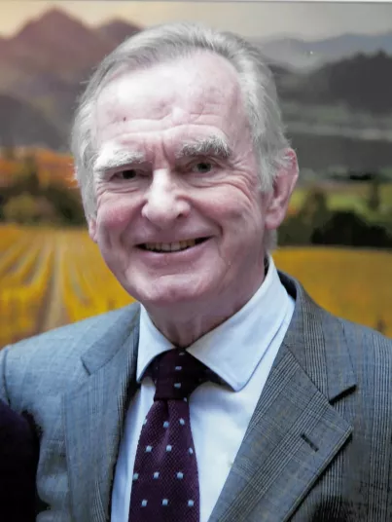At times in life, it takes just one person. One person to see a need and respond. How we respond depends on our resources, our capacity and our capability, but whether we respond or not is down to our nature and desire to make a difference.

Mr Robin Clark OBE was someone who wanted to make a difference; someone who saw a need and responded. He also recognised the benefits of speech and language therapy. But Robin could see that there was much that we didn’t know and that research could be the route to increasing our understanding of both the causes and best interventions for those living with communication difficulties.

Mr. Robin Clark

In response to this, Robin provided the support that was needed to establish the Speech Therapy Research Unit at Frenchay Hospital in 1987. This was a time when research in the discipline was in its infancy and the establishment of the unit on an NHS site was truly groundbreaking.

Thirty-seven years later, and renamed as Bristol Speech and Language Therapy Research Unit, we are still going strong. Through the Underwood Trust, Robin and the other trustees have provided BSLTRU with the core support needed to maintain the unit, enabling the submission of a wide range of grants from a broad range of agencies which together have advanced our knowledge, understanding and practice of speech and language therapy leading to improvements in its evidence-base, effectiveness and efficiency.

Earlier this year, Robin passed away after a period of illness. A quiet and thoughtful man, he rejected plans to name BSLTRU after him, preferring instead for his contributions to be acknowledged in a more discrete way. We are hugely grateful to Robin’s family and the Underwood Trust trustees for their ongoing support of the work of BSLTRU and their commitment to supporting the population of people affected by communication impairment. And we thank Robin, for being that one person who saw a need and did something.

Yvonne, Prof Yvonne Wren Director, BSLTRU

Contents

Introduction 2

BSLTRU activities – April 2023 to July 2024 5

1. BSLTRU People 9

1.1 BSLTRU Team 9

1.2 Postgraduate students, placements and internships 9

1.3 BSLTRU Steering Group 9

2. Funding and grant applications 10

3. Project updates 11

3.1 Wales speech language and communication identification, intervention and evaluation package 11

3.2 Understanding the impact of the COVID-19 pandemic on the early speech and language development of children born with cleft lip and/or palate. 12

3.3 Scoping review of technology used in the surveillance of children’s early speech, language and communication development. 12

3.4 Exploring access to Speech and Language Therapy for Welsh speaking survivors of stroke. 13

3.5 Supporting Spoken Language in Classrooms (SSLiC) 14

3.6 Maximising the Impact of Speech and Language Therapy for children with Speech Sound Disorder (The MISLToe_SSD study) 14

3.7 Softly non-spoken: soft robotics as non-verbal communication aids 15

3.8 The CHATTER Study: Children’s Activities and Talk in their Everyday Routines 16

3.9 The Cleft Collective Speech and Language Study 17

3.10 Unspoken Voices: What are the perspectives of people who use alternative and augmentative communication (AAC) on the impact and effectiveness of AAC equipment? 18

4. Research outputs and engagement 19

4.1 Publications 19

4.2 Indicators of esteem 22

4.3 Presentations and conferences 24

4.4 Public and Patient Involvement & Engagement (PPIE) 30

4.5 Social Media 32

5. Glossary of Terms 32

Published July 2024 33

©North Bristol NHS Trust 2024 33

Contact – dominika.kruszynska@nbt.nhs.uk 33

# BSLTRU activities – April 2023 to July 2024

From left: Jamie Perry, Taylor Snodgrass, Lucy Southby. 



*From left*: Jamie Perry, Taylor Snodgrass, Lucy Southby. **ACPA** (American Cleft Palate-Craniofacial Association Meeting), Raleigh, North Carolina, May 2023.

A group of women standing in front of a poster

 Two women standing in front of a board



*From Left:* Yvonne Wren and Cymie Ng of the Chinese University of Hong Kong at **ICPLA** (International Clinical Linguistics and Phonetics Association) conference in Salzburg, Austria, July 2023.

*From left:* Yvonne Wren, Marisa Lousada (University of Aveiro) and Ana Margarida Ramalho (University of Lisbon) at **ICPLA** (International Clinical Linguistics and Phonetics Association) conference in Salzburg, Austria, July 2023.

A group of women standing in front of a large screen

 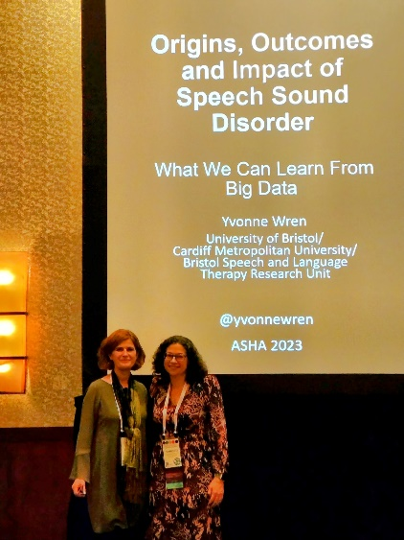

*From left:* Helen Stringer, Sam Burr, Joanne Cleland and Yvonne Wren at **ASHA** (American Speech Language Hearing Association) Conference in Boston, US, November 2023.

*From left:* Yvonne Wren and Francoise Brousseau Lapre from Purdue University at **ASHA** (American Speech Language Hearing Association) Conference in Boston, US, November 2023.

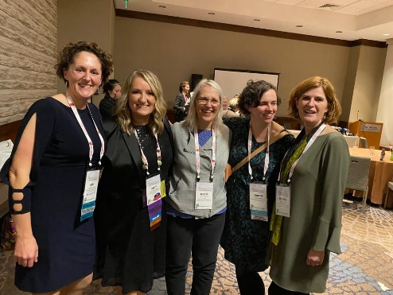 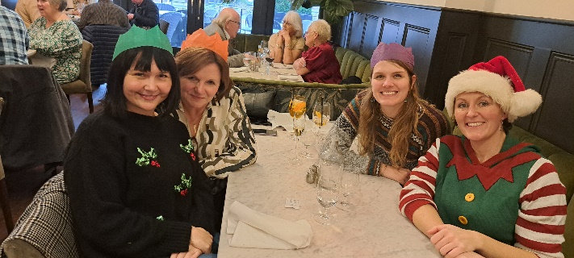

*From left*: Dominika Kruszynska, Fay Smith, Caitlin Holme and Sam Burr at Christmas meal in December 2023.

*From left*: Sam Burr, Kelly Farquharson, Helen Stringer, Joanne Cleland, and Yvonne Wren at **ASHA** Conference in Boston, US, November 2023.

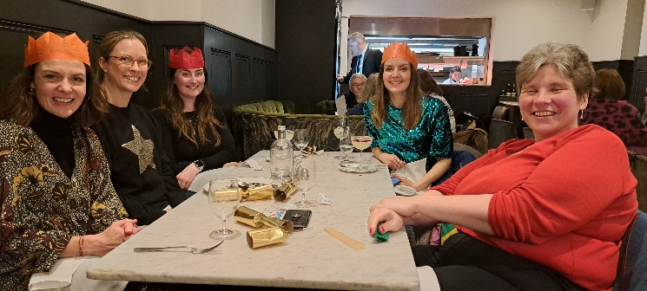

*From left*: Kath Broomfield, Lucy Southby, Charlotte McCarthy, Lydia Morgan and Sam Harding at Christmas meal in December 2023.

0

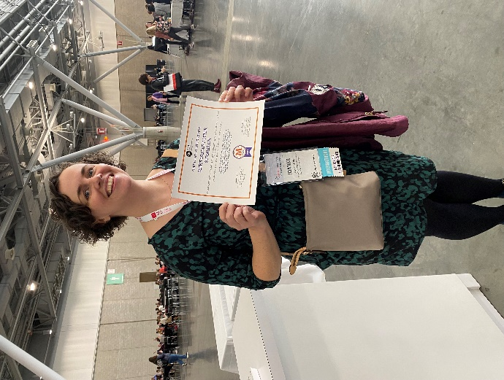

Joanne Cleland at **ASHA** Conference in Boston, US, November 2023.

*From left*: Fei Zhao, Rhonwen Lewis, Jiaying Li, Rhiannon Phillips, Ria Bayliss, Robert Mayr, Yvonne Wren, Sam Burr, Charlotte McCarthy, Sharynne McLeod at the **CSHCR Strategy Day** at Cardiff Metropolitan University, Cardiff, UK, May 2024.

*From left*: Sharynne McLeod, Caitlin Holme, Rhonwen Lewis, Charlotte McCarthy, Sam Harding, a Guest, Yvonne Wren, a Guest, Sam Burr, a Guest, Claire Butler, a Guest, Sue Roulstone at BSLTRU and Underwood Trust Annual Lecture at Southmead Hospital, Bristol UK, April 2024.

Sharynne McLeod presenting at BSLTRU and Underwood Trust Annual Lecture at Southmead Hospital, Bristol UK, April 2024.

Sharynne McLeod at University of Bristol, Bristol UK, May 2024.

Sam Burr presenting at **BAAP** (The British Association of Audiovestibular Physitians) conference, in Cardiff, UK, March 2024.

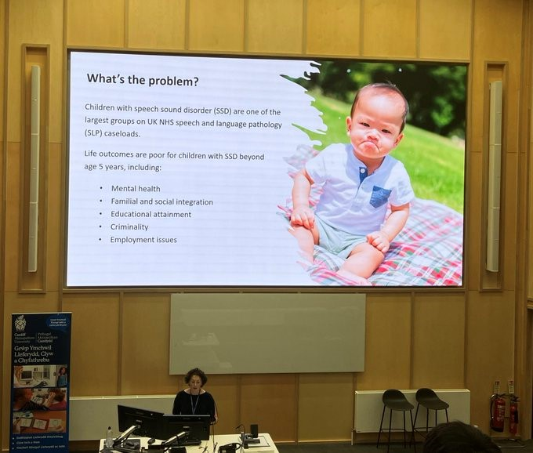

*From left*: Fei Zhao, Rhonwen Lewis, Jiaying Li, Rhiannon Phillips, Ria Bayliss, Robert Mayr, Yvonne Wren, Sam Burr, Charlotte McCarthy, Sharynne McLeod at the **CSHCR (Centre for Speech, Hearing & Communications) Strategy Day** at Cardiff Metropolitan University, Cardiff, UK, May 2024.

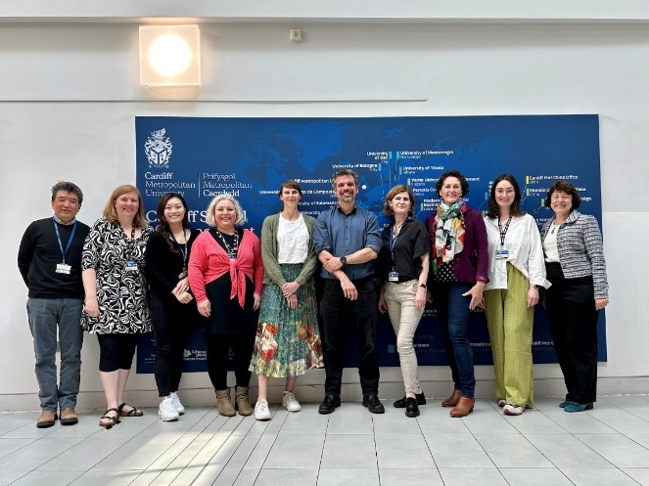

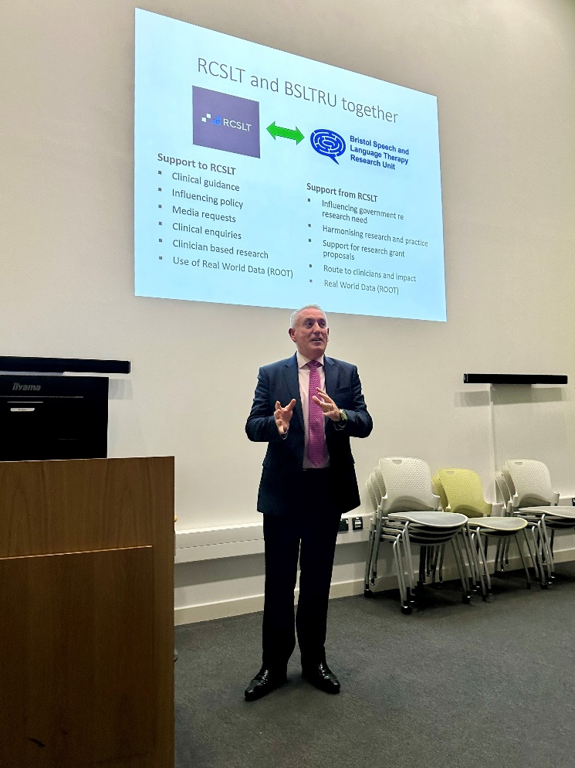

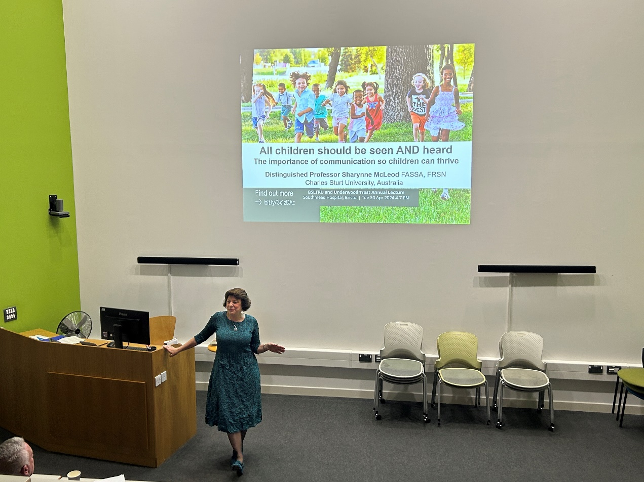

Sharynne McLeod presenting at BSLTRU and Underwood Trust Annual Lecture at Southmead Hospital, Bristol UK, April 2024.

Steve Jamieson RCSLT (Royal College of Speech and Language Therapists), at BSLTRU and Underwood Trust Annual Lecture at Southmead Hospital, Bristol UK, April 2024.

*From left*: Sharynne McLeod, Caitlin Holme, Rhonwen Lewis, Charlotte McCarthy, Sam Harding, a Guest, Yvonne Wren, a Guest, Sam Burr, a Guest, Claire Butler, a Guest, Sue Roulstone at BSLTRU and Underwood Trust Annual Lecture at Southmead Hospital, Bristol UK, April 2024.

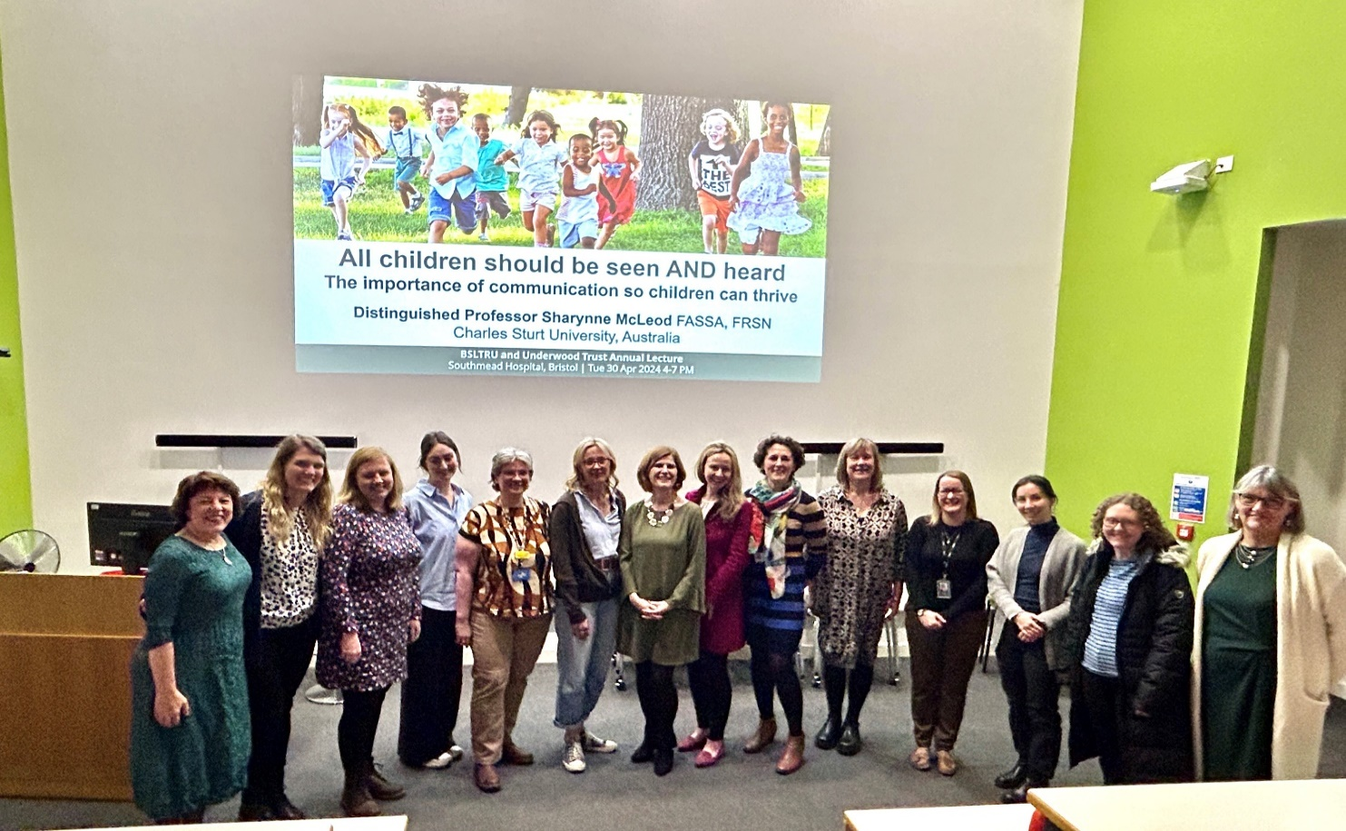

# BSLTRU People

BSLTRU consists of a core workforce of research and support staff who work in partnership with our honorary staff, students, clinical interns and volunteers.

## 1.1 BSLTRU Team

**Yvonne Wren** is Director of BSLTRU and Professor in Speech and Language Therapy at Cardiff Metropolitan University. She is also Professor of Speech and Communication at the University of Bristol Dental School. Our core team consists of **Dr Sam Harding, Dr** **Sam Burr** and **Dr Kath Broomfield** in research roles; **Caitlin Holme** who is a PhD student funded by the Heather van der Lely foundation; and **Dominika Kruszynska** and **Charlotte McCarthy** as Administrator and Research Operations Manager. We are also grateful to our bank staff who work with us including **Sharon Baker, Jill Titterington, Laura Hrastelj** and **Jenny Short**. This year we were sad to say goodbye to **Dr Lydia Morgan** and **Dr Lucy Southby** and wish them well in their next chapters.

## 1.2 Postgraduate students, placements and internships

BSLTRU continues to support clinical speech and language therapists and others researching in the field of speech, language and communication who are keen to embark on academic careers. This year, Kath Broomfield successfully defended her thesis and became Dr Broomfield while Caitlin Holme submitted her thesis in June 2024. In April 2024 we welcomed **Shani Ackford** as part of her NHS England internship. We look forward to welcoming **Phillipa Clay** and **Elizabeth Rajan** who will be joining us in the new year, following their successful applications to the NIHR Doctoral Clinical Academic Fellowship and Southwest Integrated Clinical Academic internship schemes respectively.

## 1.3 BSLTRU Steering Group

BSLTRU continues to be well supported by the BSLTRU Steering Group who maintain oversight and governance of the BSLTRU for the achievement of the unit objectives. This past year, we were sad to say goodbye to **Professor David Wynick** who has been part of the Steering Group for many years as part of his role as Director of Research for North Bristol NHS Trust. We welcome **Professor Fergus Caskey** in his place as well as **Amit Kulkarni** who is joining the group representing the Royal College of Speech and Language Therapists. Other members of our steering group **Professor Sue Roulstone** and **Professor Pam Enderby** (previous Directors of BSLTRU), **Professor Tim Peters** from the University of Bristol, **Professor Philip James** from Cardiff Metropolitan University and **Dr Toity Deave** from the University of the West of England.

# Funding and grant applications

BSLTRU is sustained by research funding and bidding is a core part of our activity. Over the past year, we have applied for 15 competitive grant applications to a variety of charity, UKRI and NIHR funding streams. We have had a successful outcome for four of these to date, with a total value of £2,014,950.00 and are awaiting the outcome of a further two. Notable amongst these is the £2million NIHR Programme Grant with the University of Bristol, led by Yvonne Wren. In this programme of work we will explore variation in outcomes for young adults born with cleft lip and/or palate at the end of routine care and identify ways to address variation which is observed.

We continue to be supported by The Underwood Trust and are immensely grateful to their Legacy Fund, which is sustaining the activity of the Cleft Collective study as well as building research capacity in the speech and language therapy workforce. We are pleased to report that Dr Sam Burr and Dr Kath Broomfield have been appointed to the Underwood Trust funded Senior Research Fellow post at Cardiff Metropolitan University.

# 3. Project updates

Over the past year, 5 projects have been completed and 6 new studies have begun. Our ongoing work includes grant funded research, doctoral and masters fellowship studies and collaborative work with other institutions. A summary of each study is provided below.

## 

## 3.1 Wales speech language and communication identification, intervention and evaluation package

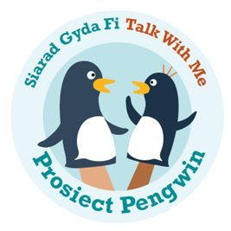**Investigators: Yvonne Wren**, Jenna Charlton, Caroline Floccia, Louisa Reeves, Cristina McKean, Carol Payne, Vicky Gilroy, Robert Mayr, Toity Deave, Nayeli Gonzalez-Gomez, **Sam Harding**, Robert Rush, Martin Ball and Sheena Reilly.

**Project Manager: Charlotte McCarthy**

**Timescale:** June 2023 to May 2026

**Funder:** Welsh Government

This project, titled ‘Prosiect Pengwin’ has just completed its first year of delivery.

The project comprises seven work packages each designed to contribute to the core outputs of:

1. A co-produced bilingual speech, language and communication surveillance tool which identifies children in need of intervention at a universal, population, targeted or specialist level.

2. A programme of evidence-based interventions which complement the surveillance tool.

3. A training programme to support implementation of the surveillance tool and intervention programme.

The outputs will be designed to fit with the existing planned contacts in the Healthy Child Wales Programme, to meet all 14 recommendations from the BSLTRU led Review of Early Language Screening report and to reflect the preferences of the workforce and families. The impact of this work will be an evidence-based surveillance tool which can be used throughout tool to monitor and support children’s speech, language and communication development from birth to age 5.

The project has completed its piloting phase for the 15 month and 27 month testing; the 42 month tool is currently in its co-design phase. This autumn the project will begin normative data collection with families across Wales.

## 3.2 Understanding the impact of the COVID-19 pandemic on the early speech and language development of children born with cleft lip and/or palate.

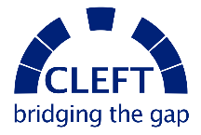**Investigators: Lucy Southby, Yvonne Wren,** Amy Davies**, Sharon Baker**, Helen Extence, Neil Brierley

**Timescale:** January 2023 - December 2023

**Funder:** CLEFT Bridging the Gap Charity

Children born with cleft palate are at risk of speech problems and delayed early language development. During the COVID-19 pandemic, treatments for children born with a cleft were often delayed and the environment that young children were exposed to was different because of lockdowns, social distancing and facemasks. This research aimed to understand whether these differences from the pandemic have had an impact on the early speech and language development of children born with a cleft. Using data from The Cleft Collective Cohort Study, this work found that there was no difference in early language skills of children who were aged 18 to 24 months before the first lockdown and those who reached 18 to 24 months of age between March 2021 and July 2022. This is a reassuring finding. It is still important that we monitor all children’s development because there will be individual variation and change over time. The findings have been presented at conferences attended by clinical teams and will be published in academic journals. A summary of the study has also been included in the Cleft Collective newsletter.

## 3.3 Scoping review of technology used in the surveillance of children’s early speech, language and communication development.

**Investigators**: **Lydia Morgan, Sam Harding, and Yvonne Wren**

**Timescale:** January 2023 – July 2023

**Funder:**  Cardiff Metropolitan University Research and Innovation Accelerator.

This scoping review built on the previous work undertaken by the BSLTRU team for the Welsh Government ([WELS-R and WIRE project](https://www.gov.wales/review-early-language-screening-suitable-children-wales-birth-5-years-summary-html?_ga=2.20469371.299278512.1675274973-634618958.1675274973)). Specifically, the aim of the work was to determine whether there is existing technology which could be adapted for use in surveillance of speech, language and communication development in children in Wales. If suitable technology is identified, the potential for an adaptation for use in Wales, to accommodate the increasing number of children growing up in families where Welsh is the language of choice, will be explored. Moreover, it will bring technology into a process that has to date been largely carried out using paper-based tools. There are potential benefits for the environment as well as for increased efficiency in the process of carrying out surveillance, vital when resources are limited, and need is universal.

## 3.4 Exploring access to Speech and Language Therapy for Welsh speaking survivors of stroke.

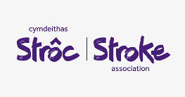**Investigators:** Carys Williams, **Yvonne Wren**, Robert Mayr, Abdul Seckam, **Katherine Broomfield**.

**Timescale:** November 2022 – August 2023

**Funder: The Stroke Association**

The aim of this project was to explore the lived experience of Welsh speakers who need speech and language therapy for aphasia following stroke to inform further research and service development.  A qualitative study was designed based on phenomenological research methodology. Three Welsh-speaking participants with aphasia took part in one-to-one interviews and a further three participants contributed to focus group. The project was co-led by Carys and Katherine and both researchers worked collaboratively throughout the project, actively engaging their complimentary skill set through journalling, peer-mentorship, and reflecting on how their experience guided their engagement with the bilingual research process. This study provides new insights into the experiences and needs of Welsh speakers with aphasia. It also highlights an innovative, collaborative process for undertaking bilingual research with people with communication disability. The results of the research indicated areas for further development of:

a) policy that can enhance the experiences and outcomes of Welsh-speakers with aphasia,

b) speech and language therapy services, and

c) support from voluntary and community services including the Stroke Association.

The forewords in the report have been written by the Welsh Commissioners Office, the RCSLT and the Stroke Association and the report itself will be launched at Eistefodd in August, subsequently being made available on the Stroke Association website. Carys and Katherine have been invited to present the project at the Welsh Stroke Association conference and the Welsh Stroke Association biannual meeting. They have also had a poster accepted at the British Aphasiology Society conference.

## 3.5 Supporting Spoken Language in Classrooms (SSLiC)

**Investigator:** Ioanna Bakopoulou (University of Bristol), **Yvonne Wren, Sam Burr, Jenny Short**.

**Timescale:** September 2023 – May 2024.

**Funder:** University of Bristol

Following the success of the SSLiC study in London, Bristol and Plymouth settings, this phase of the programme saw a second year of SSLiC undertaken in some of the settings which participated in 2022/23. Working with early years education settings in Plymouth and a number of primary schools in Bristol, the programme aimed to increase awareness and skills of staff for increasing oracy among Early Years Foundation Stage and Key Stage one children. Dr Sam Burr led the programme this year on behalf of Dr Ioanna Bakopoulou, who has been on sabbatical. Dr Burr also served as a Research Facilitator on the SSLiC study, working closely with a team of speech and language therapists and research assistants. Teaching staff were supported to use the freely available Communication Supporting Classroom Observation Tool to evaluate their practice and implement actions to bring about improvement in spoken language opportunities and skills in the classroom. The study culminated in May 2024 with evidence review days in Bristol and Plymouth enabling each setting to present their successes, learning and next steps to each other. The Education Endowment Foundation, together with the Stronger Practice Hub, have commissioned a further rollout of the SSLiC programme, and evaluation work, to settings in the Southwest in 2024/25.

## 3.6 Maximising the Impact of Speech and Language Therapy for children with Speech Sound Disorder (The MISLToe_SSD study)

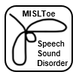**Investigators: Yvonne Wren, Sam Harding, Sam Burr,** Joanne Cleland and Helen Stringer

**Timescale:**March 2022-February 2024

**Funder:** NIHR Research for Patient Benefit (RfPB) Tier 3

This study aims to maximise the impact of speech and language therapy for children with speech sound disorder by developing a Core Outcome Set (COS) to be used by SLT services. This study comprised three workstreams, the first of which was an umbrella review to collect data to serve as content for the COS. The umbrella review protocol has been accepted for publication in BMJ Open. Workstream two brought together specialist SLTs from five NHS sites and parents of children with speech sound disorder in a participatory workshop to discuss and agree a diagnostic pathway for use with this population. Consensus was achieved through an online survey and card sorting activity. The final workstream presented the COS to an expert panel, including parents and people with lived experience, and a final consensus was reached. The planned follow-on study for this work will comprise a feasibility study using the COS with a small number of NHS sites across the UK. Key to this next phase are close, collaborative relationships with NHS IT systems teams, business development and innovation, clinicians, service managers and families to ensure data collection is feasible within the context of day-to-day clinical service delivery. The long-term impact of this work will be an agreed process for the collection of data through NHS systems on children with speech sound disorder and use of that dataset to address questions relating to the effectiveness and efficiency of the various different interventions and care pathways for children with speech sound disorder. An application for funding of the feasibility study has been shortlisted to stage 2 of the NIHR RfPB Programme call for Under-served professions.

## 3.7 Softly non-spoken: soft robotics as non-verbal communication aids

**Investigators: Katherine Broomfield**, Hemma Philamore, Alice Haynes, Richard Sewell, Alison Oldfield

**Timescale:** October 2021 - Ongoing

**Funder:** EPSRC Impact Accelerator award

Softly non-spoken is an ongoing project exploring use of soft robotics to develop non-verbal communication aids (also known as augmentative and alternative communication (AAC)) for people with communication difficulties. This multi-disciplinary team brings together speech and language therapists, researchers in communication, and roboticists from academia and industry to investigate the use of current soft robotics research in a new, and often overlooked, healthcare and educational application. We developed some prototype soft-robotics and demonstrated them with professionals with experience of working with people who use AAC at the Communication Matters conference in Leeds and with young people and their parents at the Bristol Futures event at the SS Great Britain. A paper about the project was accepted in the SIGCHI conference 2024: <https://programs.sigchi.org/chi/2024/program/content/151076> . Softly-non Spoken led to a further collaboration with the Bristol Robotics Lab and Air Giants, funded by the Bristol Digital Futures Institute (BDFI): Wearable Autonomous Robots for Embodied Communication. This project has seen the collaboration grow to include Neon Dance company to explore the potential for giant soft robotics to support the expression of embodied communication. We are currently developing a film about this project and a grant application is being prepared for the Leverhulme Trust.

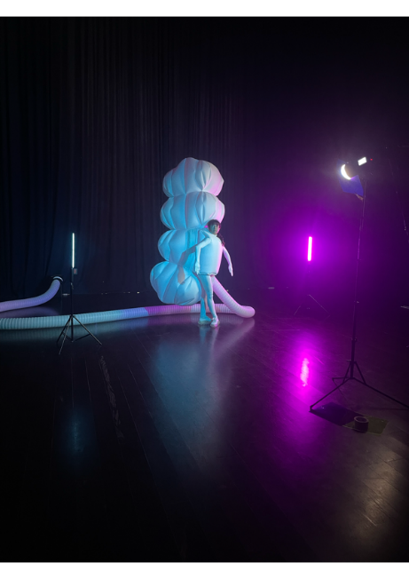

Neon Dance company demonstrates expression of embodied Communication, Bristol, June 2023.

## 3.8 The CHATTER Study: Children’s Activities and Talk in their Everyday Routines

**Investigator: Caitlin Holme**

**Timescale:** June 2020 – June 2024

**Funder:**  Heather van der Lely Foundation

This study was conducted by Caitlin Holme as part of her PhD at the University of Bristol and was funded by the Heather van der Lely foundation. The goal of this qualitative study was to explore variation in a diverse group of families’ everyday interactions and activities and use this information to consider how parent-child interaction (PCI) approaches can work best for the families that speech and language therapists work with. The work is now complete and Caitlin submitted her thesis in June 2024. Her viva is scheduled for early August.

The study used an ethnographic approach to collect a range of data from families, including day-long audio recordings, photographs, parent interviews and timelines of families’ everyday routines. Results show complex variation in how families engage in activities, and the times of day that provide opportunities for interaction in each family. Analysis of parent interviews suggest that a range of inter-connected factors influence children’s everyday interactions, including their own temperament, their parents’ priorities, and their wider cultural and societal context. Recommendations for speech and language therapists using PCI approaches in clinical practice include finding time that fits the family, understanding the individual family culture, and engaging in collaborative practice.

For more information about the study see the website: <https://www.nbt.nhs.uk/bristol-speech-language-therapy-research-unit/bsltru-research/chatter-study>.

You can watch a Youtube video of Caitlin talking about the study here: <https://www.youtube.com/watch?v=DzOKphACBOw>

## 3.9 The Cleft Collective Speech and Language Study

**Investigator: Yvonne Wren, Sam Harding and Lucy Southby**

**Timescale:** December 2014 to March 2027.

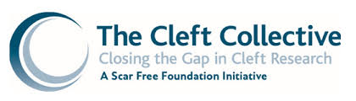

**Funder:** Scar Free Foundation, The Underwood Trust,

University of Bristol

The Cleft Collective Cohort Study investigates the biological and environmental causes of cleft lip and/or palate, the best treatments for cleft and the impact of cleft on those affected and their families. With the help of every cleft team in the UK, children and their families are being recruited into the studies. They contribute biological samples (such as saliva) and complete a number of questionnaires at important time points during their child’s development. The Cleft Collective Speech and Language study (CC-SL) is a nested study within the main birth cohort study and is hosted by BSLTRU. The CC-SL study is collecting data on speech outcomes in children born with cleft palate as well as measures of parent-child interaction, infant vocalisations, the audio environment, speech and language therapy assessments at 18-24 and 36 months, speech and language therapy intervention up to age 5 and hearing assessment data. For more information about The Cleft Collective cohort studies, please see:

<http://www.bristol.ac.uk/cleft-collective/> and <https://www.nbt.nhs.uk/bristol-speech-language-therapy-research-unit/bsltru-research/cleft-speech-language-study> .

The dataset is made available to other researchers to allow a range of investigations to be carried out with the potential for clinical impact.

**Hosted Projects**

In addition to the speech and language therapists who are fellowship or internship awardees and supervised directly by BSLTRU staff, we also host speech and language therapists who are NIHR Doctoral Clinical Academic Fellowship award holders who are local to the area but registered at a distant institution. The hosting arrangement means that we do not provide supervision but instead provide a research environment and networks with local clinical academics. Kath Broomfield’s recently completed fellowship is one of these; next year we will welcome Philippa Clay on the same scheme.

## 3.10 Unspoken Voices: What are the perspectives of people who use alternative and augmentative communication (AAC) on the impact and effectiveness of AAC equipment?

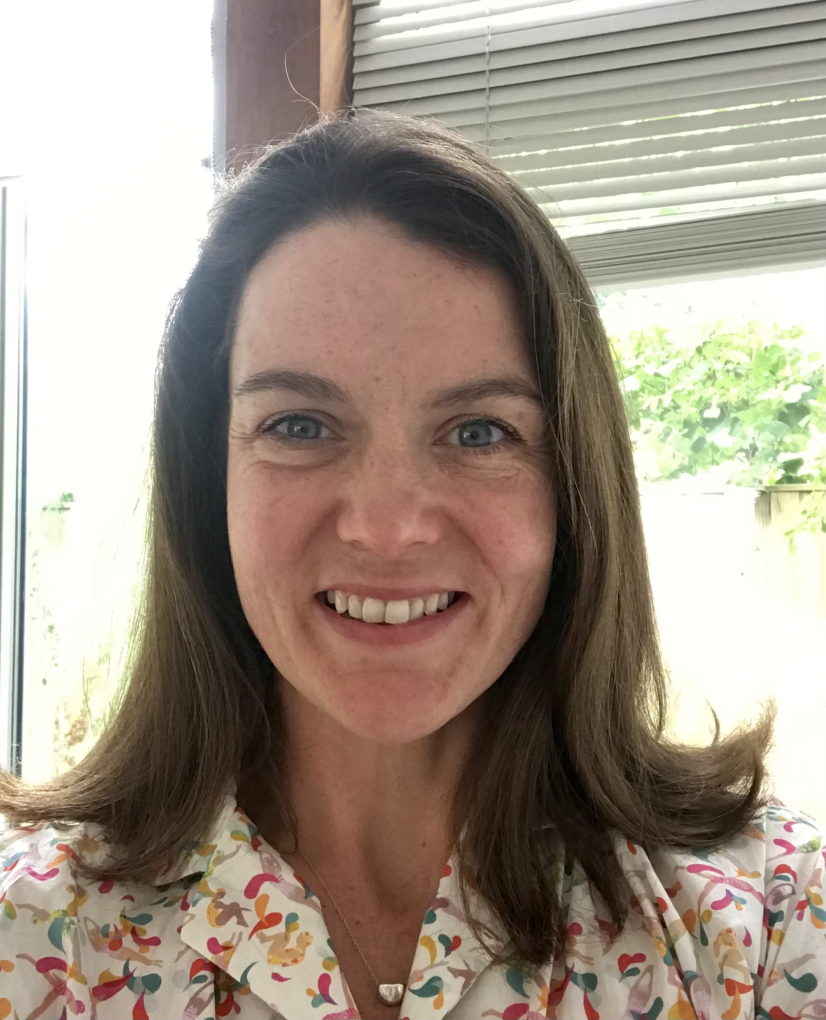

**Investigator:** Katherine Broomfield (Manchester Metropolitan University) **Timeline:** April 2017-September 2022 **Funder:** HEE/NIHR Clinical Doctoral Fellowship

This project is concerned with people who use augmentative and alternative communication (AAC) because they cannot speak clearly or cannot speak at all.  AAC refers to a set of strategies such as pointing to pictures, words or letters as well as the use of special equipment including computer-based devices that can speak out messages entered into or stored within it. The aim of this research project was to understand more about people’s experience of using AAC to communicate to inform the development of clinical tool that will evaluate AAC interventions from the perspective of the patient. Katherine completed her fellowship in Sept 2022 and was awarded her PhD in January 2024. She has published 5 papers from her PhD, has one book chapter due for publication this autumn, and a second due for publication next year. She co-authored a book about service user involvement: <https://www.jr-press.co.uk/product/seldom-heard-voices/> and has been invited to give a conference keynote and several workshops about public involvement with people who have communication disability.

Katherine secured an NIHR post-doctoral bridging grant from NHS South West Workforce Transformation (previous Health Education England) to continue to publish from her PhD and to prepare an application for a post-doctoral fellowship to further developing the person-centred outcome measure for people who use AAC.

# 4. Research outputs and engagement

## 4.1 Publications

The unit continues to publish both as lead and co-authors with 21 publications in respected peer-reviewed journals for the field and four in non-peer reviewed publications and grey literature in the past year.

**Published- peer reviewed**

1. **Wren, Y.** (In press) Editorial for special issue on terminology in Speech Sound Disorder. I*nternational Journal of Language and Communication Disorders*
2. Davies, A., Humphries, K., Lewis, S., Ho, K., Sandy, J., **Wren, Y.** (2024). The Cleft Collective: protocol for a longitudinal prospective cohort study. *BMJ Open. 14:e084737.* <https://doi.org/10.1136/bmjopen-2024-084737>
3. **Harding, S., Burr, S.,** Cleland, J., Stringer, H., **Wren, Y.** (2024) Outcome measures for Children with Speech Sound Disorder: An Umbrella Review. *BMJ Open* Apr 29;14(4):e081446. <https://doi.org/10.1136/bmjopen-2023-081446>
4. **Harding, S.,** Kelić, M., Ulfsdottir, T.S., Baena, S., Feilberg, J., Klatte, I., Lyons, R., Jensen de Lopez, K.M., Novogrodsky, R., Rodriguez-Ortiz, I.R. & Zajdó, K. (2024) Rearing a child with language disorder: Parents experiences with speech and language therapy services in 10 countries. *Journal of Public Health* - <https://doi.org/10.1007/s10389-024-02264-5>
5. Davies, A., Davies, A., Main, B., **Wren, Y.,** Deacon, S., Cobb, C., McLean, N., David, D. & Chummun, S. (2024) Association of perioperative antibiotics with the prevention of postoperative fistula following cleft palate repair. *Plastics and Reconstructive Surgery Global Open* 12(2):p e5589 <https://doi.org/10.1097/GOX.0000000000005589>
6. Bolnykh, I., Sharp, L., Watson, L-J., **Harding, S.,** Patterson, J.M. (2024) Cancer-related pain in head and neck cancer survivors: longitudinal findings from the Head & Neck 5000 cohort. *Journal of Cancer Survivorship* Feb 29. <https://doi.org/10.1007/s11764-024-01554-x>
7. **Southby, L**. (2024). Considering the role of speech processing in cleft related speech sound disorders: Implications for causal pathways and classification systems. *International Journal of Language and Communication Disorders*. 1-11. <https://doi.org/10.1111/1460-6984.12993>
8. Gibbard, D., **Roulstone**, **S**., Kandala, N.II., Markham, C., **Morgan**, **L**., **Harding**, **S**.& Smith, C. (2024) A randomised controlled trial of the effectiveness of parent-based models of speech and language therapy intervention for 2- to 3-year-old children with primary language delay in areas of social disadvantage. *International Journal of Language and Communication Disorders.* Jan 29. <https://doi.org/10.1111/1460-6984.13016>
9. **Broomfield K**., Judge, S., Sage K., Jones, G.L., & James, D. (2024) Using longitudinal qualitative research to explore the experience of receiving and using augmentative and alternative communication. *International Journal of Language and Communication Disorders.* May-Jun;59(3):1043-1065. <https://doi.org/10.1111/1460-6984.12981>
10. Al Hassani, M., Fowler, P., **Wren, Y**., Leary, S., Davies, A. (2024). Should left and right sided unilateral cleft lip and palate patients be grouped together when reporting outcomes? *Orthodontics and Craniofacial Research.* <https://doi.org/10.1111/ocr.12747>
11. Fell, M., Bradbury, D., Chadha, A., Butterworth, S., Davies, A., Russell, C., Richard, B., **Wren, Y.**, Lewis, S.* Chong, D.* (2024). Sidedness in unilateral cleft lip: A systematic scoping review. *Cleft Palate and Craniofacial Journal.* <https://doi.org/10.1177/10556656231221027>
12. Chadd, K., **Harding**, **S**., Mortley, J., Enderby, P. (2024) There is more to evidence-based practice than evidence. COVID19: accelerating innovation in aphasia. *Advances in Communication and Swallowing.* vol. 27, no. 1, pp. 17-27
13. Stringer, H., Rees, R., Cleland, J., Williams, P., **Wren, Y**. Speech sound disorder or DLD (phonology)? (2024). Towards a consensus agreement on terminology. *International Journal of Language and Communication Disorders: Special Issue on Terminology*. <https://doi.org/10.1111/1460-6984.12989>
14. Nicoll, A., **Roulstone, S**., Williams, B. & Maxwell, M. (2023). Understanding capacity for implementing new interventions: A qualitative study of speech and language therapy services for children with speech sound disorder. *International Journal of Language and Communication Disorders.* <https://doi.org/10.1111/1460-6984.12979>
15. Hesketh, E., White, P. Simkiss, D., & **Roulstone, S**. (2023). Outcomes from a community speech and language therapy service treatment waiting list: The natural history of 527 children with identified speech and language needs. *International Journal of Language and Communication Disorders. 58:1510-1525.* <https://doi.org/10.1111/1460-6984.12877>
16. Nicoll, A., **Roulstone, S**., Williams, B. & Maxwell, M. (2023). Understanding capacity for implementing new interventions: A qualitative study of speech and language therapy services for children with speech sound disorder. *International Journal of Language and Communication Disorders.* <https://doi.org/10.1111/1460-6984.12979>
17. Rodgers, L., Botting, N., Cartwright, M., **Harding, S.,** & Herman, R. (2023). The shared characteristics of intervention techniques for oral vocabulary and speech comprehensibility; protocol for a systematic review and narrative synthesis. *BMJ Open* <https://bmjopen.bmj.com/content/13/6/e071262>
18. Burnley, A., St Clair, M., Bedford, R., **Wren Y.,** Dack, C. (2023). Understanding the prevalence and manifestation of the anxiety and social difficulties experienced by children with Developmental Language Disorder. *Journal of Neurodevelopmental Disorders*. 15, 17 <https://doi.org/10.1186/s11689-023-09486-w>
19. Sainsbury, D., Williams, C., Butterworth, S., de Blacam, C., Fell, M., Mullen, J., Breakey, W., Murphy, C., Hodgkinson, P. & **Wren, Y.** (2023). Patient Factors Influencing Speech Outcomes in Velopharyngeal Function Following Initial Cleft Palate Repair: A Systematic Review and Meta-Analysis. *The Cleft Palate Craniofacial Journal*. <https://doi.org/10.1177/10556656231191384>
20. Gamble, C., Persson, C., Willadsen, E., Albery, L., Soegaard Andersen, H., Zattoni Antoneli, M., ... **Southby, L (48/60 authors**) … & Shaw, W. (2023). Timing of Primary Surgery for Cleft Palate. *New England Journal of Medicine*, *389*(9), 795-807. [DOI: 10.1056/NEJMoa2215162](DOI:%2010.1056/NEJMoa2215162)
21. Sharp, L,. Watson, LJ., Lu, L., **Harding, S.,** Hurley, K., Thomas, S.J., Patterson, J.M. (2023). Cancer-related fatigue in head and neck cancer survivors: longitudinal findings from the Head and Neck 5000 prospective clinical cohort. *Cancers*. 15(19), 4864; <https://doi.org/10.3390/cancers15194864>

**Published - non peer reviewed**

1. **Holme, C., Harding, S., Roulstone**, S., Lucus, P.J. & **Wren, Y.** (2023). Mapping the literature on parent-child language across activity contexts: a scoping review. In *Young Children’s Language in Context* [Ed Degotardi, S., Stagg Peterson, S. & Hu, J.] Available from: <https://www.routledge.com/Young-Childrens-Language-in-Context/Degotardi-Peterson-Hu/p/book/9781032459974>
2. Burnley, A., Burke, C., St Clair, M., **Wren, Y.**, & Dack, C. (2023). Informing the development of a novel intervention targeting the psychosocial skills of children with developmental language disorder: a systematic review of existing parent-led interventions. *Journal of Medical Internet Research Publications* Preprint <https://preprints.jmir.org/preprint/49843>
3. **Baker, S., Short, J., Harding, S**., Lewis, R., Mayr, R., **Roulstone, S**., McKean, C., Williams, A. & **Wren, Y.** (2023). Supporting Speech, Language and Communication (SLC) Development in the Early Years: An Evidence Review of Universal, Population and Targeted Interventions. Cardiff: Welsh Government, GSR report number 73/2023 Available at: <https://www.gov.wales/interventions-review-supporting-early-years-speech-language-and-communication-slc>
4. Fell, M., Bradley, D., Chadha, A., Butterworth, A., Davies, A., Russell, C., Richard, B., **Wren, Y.,** Lewis, S., Chong, D. (2024). Sidedness in unilateral orofacial clefts: A systematic scoping review. medRxiv 2023.09.06.23295169; <https://doi.org/10.1101/2023.09.06.23295169>

## Indicators of esteem

Members of the BSLTRU team have been invited to participate in a variety of activities in recognition of the work we carry out to understand the nature of speech, language and communication impairments and what we can do to help. This is important as this is how we can communicate the findings from our research to audiences who can use those findings to make changes to how we intervene and work with people with communication impairments.

**Members of BSLTRU have been invited to give talks on topics related to the research we carry out:**

1. **Lucy Southby** invited presentation at the national Cleft and Craniofacial SLT Clinical Excellence Network in Cardiff on ‘Using QI (Quality Improvement) to improve access to SLT intervention for children with cleft speech characteristics’. (April 2023).
2. **Southby, L**. invited presentation at Centre for Language and Communication Research, Cardiff University. (June 2023).
3. **Wren, Y.** Invited presentation at American Speech-Language and Hearing Association Convention, Boston, USA. (November 2023).
4. Baker, S., **Harding, S**. Wales Speech Language & Communication (SLC) Study Day - Wales Intervention review – Online webinar. (December 2023).
5. **Broomfield, K**. Invited workshop to the Bristol North Sommerset & South Gloucestershire (BNSSG) stroke rehabilitation speech and language therapists, Bristol. (Feb/March 2024).
6. **Burr, S.** Invited talk at Cleft and Craniofacial CEN, Manchester. (April 2024).
7. **Southby, L**. Invited talk at Spires Cleft Centre 20th Anniversary research conference/CPD day. (May 2024). (Declined).
8. **Wren, Y**. Speaker at Women to Professor’s Conference at Cardiff Metropolitan University, Wales. (May 2024).
9. **Wren, Y**. Language as a human right – The role of speech and language therapy in giving voice to the voiceless. Plenary speaker at iMean7 Conference, University of the West of England, Bristol, UK. (June 2024).
10. **Broomfield, K** and Williams, C. Invited presentation at the Welsh Stroke Conference, Cardiff. (June 2024).
11. **Broomfield, K** and Williams, C. Invited presentation at the Welsh Stroke Association biannual meeting, Cardiff. (June 2024).
12. **Broomfield, K.** Invited workshop at Northeast SLT Research Network CEN, Newcastle. (July 2024).
13. **Burr, S**. Invited talk on PPIE at Northeast SLT Research Update event, Newcastle. (July 2024).
14. **Burr, S**. Invited talk at NBT Innovate to Improve internal event. Bristol. (July 2024).
15. **Wren, Y**., Lewis, S., Stergiakouli, E. ‘Investigating the causes, outcomes and impact of cleft lip and palate – building on a legacy of research at Bristol Dental School’. University of Bristol Population Health Sciences Institute Annual Symposium. (July 2024).
16. **Wren, Y**. Keynote speaker at FORL (Otorhinolaryngology Foundation) Congress, Sao Paolo, Brazil. (September 2024). Accepted.

**Other measures of esteem**

1. **Yvonne Wren** was awarded Professorships from Cardiff Metropolitan University and University of Bristol. (August 2023).
2. The MISLToe_SSD team (**Harding, Burr,** Cleland, Stringer, **Wren**) were awarded ‘Best Abstract’ prize at the RCSLT Conference for Maximising the Impact of Speech Therapy for Children with Speech Sound Disorder – The MISLToe_SSD Study: What we found out and its application to other clinical areas. (Nov 2023).
3. The MISLToe_SSD team (**Harding, Burr,** Cleland, Stringer, **Wren**) were nominated for the 2024 Royal College of Paediatric Child Health (RCPCH) Paediatric Involvement and Engagement in Research (PIER) Award.
4. **Lucy Southby** was invited to a parliamentary reception at the House of Commons for raising awareness of Childhood Apraxia of Speech and SLCN (October 2023).
5. The MISLToe_SSD team were nominated for the COMET Impact Award 2023.
6. **Sam Burr** was invited to join the grant advisory group for ERC-awarded/UKRI-funded project "*Identifying the role of sensorimotor feedback as a mechanism of language learning in the first three years of life*” by Principle Investigator Dr Catherine Laing from the University of York (2024-2029).

## 4.3 Presentations and conferences

In addition to the invited presentations, we have also had 3 panels, 31 oral papers and 11 posters accepted for presentation at conferences, both national and international.

Panel presentations

1. **Wren, Y**., Chapman, K., van Eeden, S, Chong, D., **Southby, L**., Humphries, K., Davies, A., van Eeden, S., Fell, M. Evidence based clinical practice: what can we learn from large multi-center longitudinal studies? American Cleft Palate Association Conference, Denver, Colorado (Accepted Panel – April 2024).
2. **Wren Y.,** Stringer, H., Petinou, K., Clausen, M., **Southby, L**., Holt, Y. What’s in a name: How should we describe and define speech sound disorder and why does it matter? *International Clinical Phonetics and Linguistics Association Conference, Salzburg Austria.* (July 2023).
3. McLeod, S., Blake, H. … **Wren, Y.,** … Children’s speech development in 70+ languages and dialects. *International Clinical Phonetics and Linguistics Association Conference, Salzburg Austria.* (July 2023).

Paper Presentations

1. **Burr, S.**, Cleland, J., **Harding, S**., Stringer, H. and **Wren, Y**. Development of a Core Outcome Set for children with Speech Sound Disorder: The MISLToe_SSD study phase 1. *European Speech and Language Therapy Association,* Bruges,(September 2024).
2. **Burr, S.**, Cleland, J., **Harding, S**., Stringer, H. and **Wren, Y**. Testing the feasibility of collection of a Core Outcome Set for children with Speech Sound Disorder: The MISLToe_SSD study phase 2. *European Speech and Language Therapy Association,* Bruges,(September 2024).
3. **Holme, C., Wren, Y., Harding, S., Roulstone, S**. A day in the life of 12 toddlers: studying children’s everyday interactions to inform parent-child interaction therapy. *European Speech and Language Therapy Association,* Bruges,(September 2024).
4. Rodgers, L., Herman, R. Botting, N. & **Harding, S.** Dosage specifications for a new intervention for pre-school children with developmental language disorder and speech sound disorder: insights from research and clinical expertise. *Child Language Symposium,* Newcastle University*,* Newcastle, (July 2024).
5. Oldfield, A. **Broomfield, K.,** Philamore, H.,Sewell, R. Softly Non-Spoken: Exploring the Potential of Soft Robotics to Support Non-Verbal Communication. *Computer-Human Interaction: Late Breaking Work stream,* Hawaii, USA,(July 2024).
6. **Southby, L**., Davies, A., **Baker, S**., Extence, H., Brierley, N., **Wren, Y**. Pandemic related social restrictions and early speech/language development in children born with a cleft. *Craniofacial Society of Great Britain and Ireland Conference.* Manchester, (April 2024).
7. Burnley, A., St Clair, M., Dack, C., **Wren Y**., Waldron, S., Bedford, R. Introducing the PLUTO program: A pilot trial of an online, parent-led, psychosocial intervention for children with Developmental Language Disorder*. Royal College of Speech and Language Therapists Conference*, virtual, (November 2023).
8. **Burr, S**., Cleland, J., Stringer, H., **Harding, S**. & **Wren, Y**. Maximising the Impact of Speech Therapy for Children with Speech Sound Disorder - The MISLToe-SSD Study. *American Speech-Language and Hearing Association Convention,* Boston, USA, (November 2023).
9. **Wren, Y.,** Davies, A., & Humphries, K.  Building a Resource for Cleft Research: The Cleft Collective Cohort Study. *American Speech-Language and Hearing Association Convention,* Boston, USA, (November 2023).
10. Sharp, L., Watson, L-J., Lu, L., **Harding, S.,** Patterson, J.M. Patterns and predictors of cancer-related fatigue in the year following diagnosis of head and neck cancer: longitudinal findings from the Head & Neck 5000 cohort. *International Academy of Oral Oncology,* Korea, (November 2023).
11. **Wren, Y.,** Pape, C., **Harding, S., Baker, S., Holme, C., Lewis, R. & Siefert, M.** Early identification of speech, language and communication needs: What the evidence says about the what, where, who and how. *Royal College of Speech and Language Therapy Conference,* Virtual, (November 2023).
12. Stringer, H., **Harding, S., Burr., S.,** Cleland, J. and **Wren, Y.** Maximising the impact of speech therapy for children with speech sound disorder – The MISLToe_SSD Study: What we found out and its application to other clinical areas. *Royal College of Speech and Language Therapy Conference,* Virtual, (November 2023).
13. **Southby, L.,** Chandler, H. & the Cleft.NET.East SLT team. Maximising use of cleft centre Speech and Language Therapy intervention capacity to improve access to intervention for children with cleft speech characteristics. *Royal College of Speech and Language Therapists Conference,* virtual, (November 2023).
14. **Holme, C., Wren, Y., Harding, S., Roulstone, S.** and Lucas, P.J. Presenting a novel family-centred method for studying the everyday interactions of children at risk of Developmental Language Disorder (DLD). *International Developmental Language Disorder Conference,* Virtual, (September 2023).
15. Rodgers, L., **Harding, S.,** Cartwright, M., Botting, N., Herman, R. Developing a new intervention for pre-school children with co-occurring features of Developmental Language Disorder (DLD) and Speech Sound Disorder (SSD). *International Developmental Language Disorder Conference,* Virtual, (September 2023).
16. Sharp, L., Watson, L-J., Lu, L., **Harding, S.,** Patterson, J.M. Patterns and predictors of cancer-related fatigue in the year following diagnosis of head and neck cancer: longitudinal findings from the Head & Neck 5000 cohort. *Society of Social Medicine Conference,* Newcastle, (September 2023).
17. Burnley, A., St Clair, M., Bedford, R., Waldron, S., **Wren, Y**. & Dack, C. Introducing the PLUTO program: A pilot trial of an online, parent-led, psychosocial intervention for parents/carers of children with Developmental Language Disorder. *International Conference on Child and Adolescent Psychopathology,* Sarawak, Malaysia, (August 2023).
18. **Harding, S., Burr, S.,** Cleland, J., Stringer, H. and **Wren, Y.** Outcome measures for Children with Speech Sound Disorder: An Umbrella Review. *International Association of Communication Sciences and Disorders Congress,* Auckland, USA, (August 2023).
19. **Harding, S., Burr, S.,** Cleland, J., Stringer, H. and **Wren, Y**. Children with Speech Sound Disorder: Emotional mapping to understand their experiences of speech and language therapy intervention. *International Association of Communication Sciences and Disorders Congress,* Auckland, USA, (August 2023).
20. **Burr, S**., **Harding, S**.**A**., Cleland, J., Stringer, H. and **Wren, Y**. (August 2023) Maximising the impact of speech and language therapy for children with speech sound disorder (MISLToe_SSD) – a protocol for a core outcome set. *International Association of Communication Sciences and Disorders Congress,* Auckland, USA, (August 2023).
21. **Burr, S**., Wren, Y. and Deave, T. (August 2023) The effect of feeding and non-nutritive sucking on speech sound development at ages 2 to 5 years. *International Association of Communication Sciences and Disorders Congress,* Auckland, USA, (August 2023).
22. **Roulstone, S., Morgan, L., Harding, S.,** ……..(Nuffield Project team to be confirmed) Patient Activation Measure (title to be confirmed). *International Association of Communication Sciences and Disorders Congress,* Auckland, USA, (August 2023).
23. Collaboration for Communication (this includes **Roulstone, S., and Harding., S**) Does current evidence enable SLT-parent collaboration that addresses the priorities of parents? *International Association of Communication Sciences and Disorders Congress*, Auckland, USA, (August 2023).
24. **Wren, Y.,**Stringer, H., Petinou, K., Clausen, M., **Southby, L.**, & Holt Y. What’s in a name: How should we describe and define speech sound disorder and why does it matter? *International Clinical Phonetics and Linguistics Association Conference,* Salzburg, (July 2023).
25. **Wren, Y., Harding, S., Baker**, D., Lewis, R. Early language surveillance in children growing up in bilingual environments. *International Clinical Phonetics and Linguistics Association Conference*, Salzburg Austria, (July 2023).
26. **Burr, S.,** Cleland, J, **Harding, S**., Stringer, H., **Wren, Y.** Which clinical speech metrics are used to measure outcomes of interventions for children with speech sound disorder of unknown origin? *International Clinical Phonetics and Linguistics Association Conference,* Salzburg Austria, (July 2023).
27. Mason, K., Kotlare, K., Davies, A., & **Wren, Y.** Do patient-specific anatomic factors in the first year of life influence speech outcomes for children with cleft palate at age three? *American Cleft Palate Association Conference,* North Carolina, USA, (May 2023).
28. **Southby, L**., Davies, A., Baker, S., **Wren, Y**., & Extence, H. Understanding the impact of the COVID-19 pandemic on the early language development of children born with cleft lip and/or palate. *American Cleft Palate Association Conference,* North Carolina, USA, (May 2023).
29. Simon, S., Fowler, P., Leary, S., & **Wren, Y**. The impact of COVID-19 on dental care pathways for 5-year-old children born with a cleft in the UK. *Craniofacial Society of Great Britain and Ireland,* Cardiff, UK*,* (April 2023).
30. Al-Hassani, M., Fowler, P., Leary, S., & **Wren, Y**. cLeft or Right: Does Cleft laterality matter? *Craniofacial Society of Great Britain and Ireland,* Cardiff, UK,(April 2023).
31. **Wren, Y**., Davies, J., Davidson, E., **Southby, L., Harding, S**. Understanding outcomes at transition to adult care for young people born with cleft lip and/or palate. *Craniofacial Society of Great Britain and Ireland,* Cardiff, UK,(April 2023).

Poster presentations

1. **Burr, S**., **Wren, Y**. and Deave, T. The effect of feeding and non-nutritive sucking on speech sound development at ages 2 to 5 years. *UK and Ireland Speech Workshop 2024,* University of Cambridge*,* UK*,* (July 2024).

2. **Holme, C**., **Wren, Y**. **Harding, S**. and **Roulstone, S**. A day in the life of 12 toddlers: studying children’s everyday interactions to inform parent-child interaction therapy. *Heather van der Lely research conference,* London*,* (June 2024).

3. **Holme, C**., **Wren, Y., Harding, S**. and **Roulstone, S**. A day in the life of 12 toddlers: how does parent input vary across activity contexts? *International Congress for the Study of Child Language*, (July 2024).

4. Reed, C., **Harding S**., Coward, T. Analysis of the fundamental features of observer responses to facial prosthetics worn by individuals who have undergone head cancer treatment or experienced traumatic injury: a systematic review. *British Association of Head&Neck* *Oncologists*, London*,* (May 2024).

5. Bakopoulou, I., **Burr, S**., **Wren, Y**. Evaluating the Supporting Spoken Language in the Classroom (SSLiC) Programme in Early Years and Primary School Settings in South-West England, UK. *Royal College of Speech and Language Therapists Conference.* Virtual. (November 2023).

6. Mason, K., Kotlarek, K., Davies, A., **Wren, Y**., Influence of Cleft Anatomy in First Year of Life on Speech Outcomes at Age Three. *American Speech-Language and Hearing Association Convention*, Boston, USA, (November 2023).

7. **Wren, Y**., **Harding**, S., Baker, S., Short, J. Targeting Early Speech, Language and Communication Skills Through Post-Natal Mental Health Interventions. *American Speech-Language and Hearing Association Convention,* Boston, USA, (November 2023).

8. Spear, H., Varia, M., & **Harding S**. Speech and Language Therapy in Critical Care – Establishment of a regional training package. *Royal College of Speech and Language Therapists Conference*, Virtual, (November 2023).

9. Bakolpoulou, I., **Burr, S., Wren, Y**. Evaluating the Supporting Spoken Language in the Classroom (SSLiC) Programme in Early Years and Primary School Settings in South-West England, UK. *International Association of Communication Sciences and Disorders Congress*, Auckland, USA, (August 2023).

10. Lyons, R., Carroll, C., **Harding**, S., Kelič, M., Klatte, I., Melvin, K., Sugden, E. Preparing allied health and social care students to work collaboratively with families of children with language disorders: A scoping review. *International Association of Communication Sciences and Disorders Congress*, Auckland, USA, (August 2023).

11. Williams, C. & **Broomfield, K**. Experiences of Welsh stroke survivors with aphasia. *British Aphasiology Society*, Leicester, UK, (Sept 2024).

## 4.4 Public and Patient Involvement & Engagement (PPIE)

BSLTRU continues to actively engage with members of the public and patients to ensure that our activities are relevant and meaningful to the people that matter.

We have a number of PPIE groups specific to different studies. In the Cleft Collective and Cleft@18-23, we run PPIE groups with the Cleft Lip and Palate Association, the support group for anyone impacted by cleft.

The MISLToe study has worked closely with parents and young children with speech sound disorder to explore what it is like to engage with speech and language therapy services. Dr Sam Burr was invited to share learning from this PPIE work with the Northeast SLT Research CEN and captured impact on how her talk would influence clinical and research practice among the audience going forward.

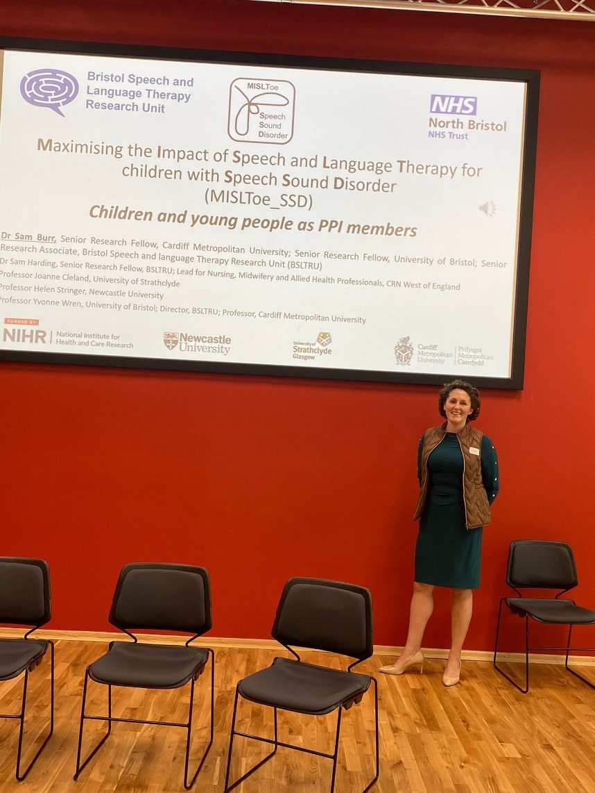

Dr Sam Burr presented at the Northeast SLT research **CEN** meeting in Newcastle, July 2024.

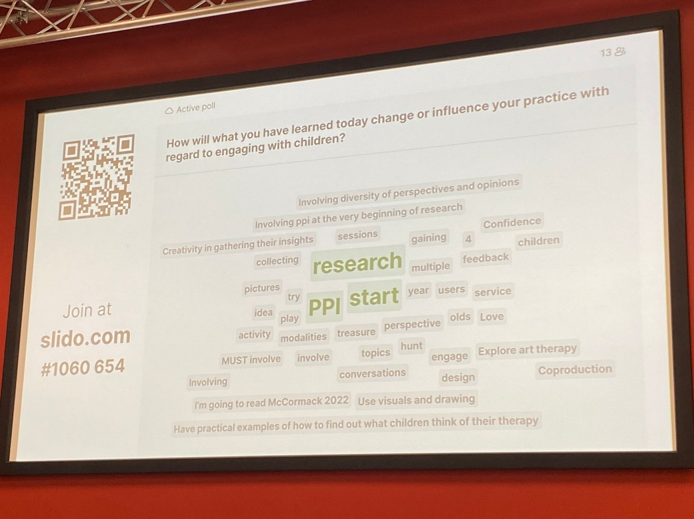

Dr Sam Burr presented at the Northeast SLT research **CEN** meeting in Newcastle and asked how the shared learning would change attendees' practice.

Kath Broomfield's work on inclusive PPI with Seldom Heard Voices continues to gather positive momentum. Kath was able to extend her creative PPIE practices to a participatory action research project with diverse ethnic communities in Gloucestershire: <https://f.io/c9Vnm6kr> . Kath's creative PPIE practice also resulted in a positive knowledge exchange visit to the Jordanstone Art and Design College at the University of Dundee in May to share learning about inclusive methods for people with complex communication disability in research with Prof Graham Pullin and colleagues at Studio Ordinary. Following on from their book "Seldom Heard voices in Service User Involvement", published in 2022, Kath Broomfield and co-editor Anna Volkmer were invited to run a workshop on public involvement in research at the North East Research Network's study day. Kath has run her first in-person PPIE group for the Unspoken Voices project since before the pandemic, welcoming 10 AAC users to 2 sessions at the National Star College in Ullenwood, Cheltenham, in June. Kath will support Shanie Ackford to host a PPIE group with people with aphasia as part of her internship in July.

## 4.5 Social Media

We work with the web team at North Bristol NHS Trust to create an accessible, innovative web site for the unit. The website homepage is [www.nbt.nhs.uk/BSLTRU.](http://www.nbt.nhs.uk/BSLTRU)

BSLTRU has several active social media platforms with a relatively small but targeted worldwide audience of key professionals, collaborators and colleagues as well as members of the public. These social media streams are an important way to help us stay connected with the speech and language therapy community world-wide, as well as providing a route of public engagement activities and recruiting to research studies.

**Ways to engage with us on social media:**

# 5. Glossary of Terms

[**https://www.linkedin.com/company/bristol-speech-and-language-therapy-research-unit**](https://www.linkedin.com/company/bristol-speech-and-language-therapy-research-unit)

**@Bristol_SLTRU**

[**https://www.facebook.com/BSLTRU/**https://www.facebook.com/BSLTRU/](https://www.facebook.com/BSLTRU/)

|  |  |
| --- | --- |
| **AAC** | Alternative and Augmentative Communication |
| **BNSSG** | Bristol, North Somerset and North Gloucestershire |
| **BSLTRU** | Bristol Speech and Language Therapy Research Unit |
| **CC-SL** | Cleft Collective Speech and Language Study |
| **CSHCR** | Centre for Speech, Hearing & Communication Cardiff Metropolitan University |
| **NIHR** | National Institute for Health and Care Research |
| **SLCN** | Speech, language and communication needs |

## Published July 2024

## ©North Bristol NHS Trust 2024

## Contact – [dominika.kruszynska@nbt.nhs.uk](mailto:dominika.kruszynska@nbt.nhs.uk)