Long Term Employment Goal

The employment goal I want to achieve is:

Now check how important your goal is to you:
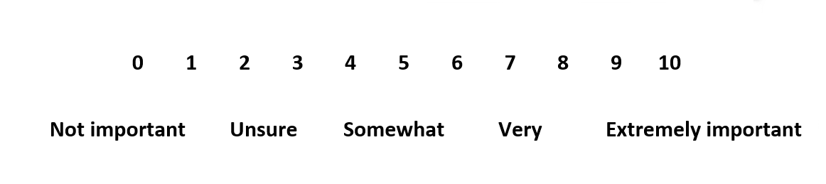
If you gave your goal a score of less than 7, you may benefit from revising your goal to make it more Relevant to you.

Now check how confident you are that you will be able to achieve your goal:
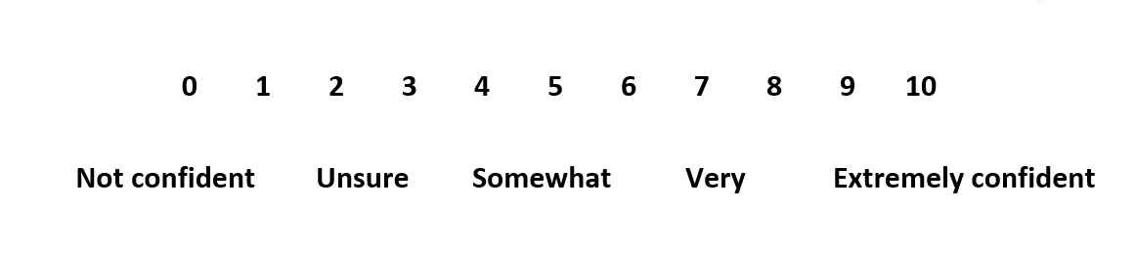
If your confidence is less than 7 out of 10, you may benefit from breaking your goal down into more achievable sections to make it more Specific and Achievable

If you needed to adjust your goal write the updated version here:

MY ACTION PLAN – the steps I need to take to reach my goal
Write down the steps you need to take to achieve your goal. Only write down as many steps as you need.
a. My first step

I intend to achieve this by the following date:
b. My second step

I intend to achieve this by the following date:
c. My third step

I intend to achieve this by the following date:
d. My fourth step

I intend to achieve this by the following date:

Barriers
The things that will make it hard for me to reach my goal
Ways I can overcome the barriers
The ways I can overcome those things that may get in my way when working towards my goal

