Appendix 2

NBT WDES DATA 2021/22
All NBT workforce data is the trust position as at 31 March 2022.

NBT Profile
Financial Year | Disabled Head Count | Disabled % | Non Disabled Head Count | Non Disabled % | Unknown Head Count | Unknown % | Head Count Total
2020/21 | 171 | 1.79% | 6995 | 73.02% | 2413 | 25.19% | 9579
2021/22 | 233 | 2.44% | 7097 | 74.37% | 2213 | 23.19% | 9543
Table: All NBT staff by disability category 2020/21 & 2021/22

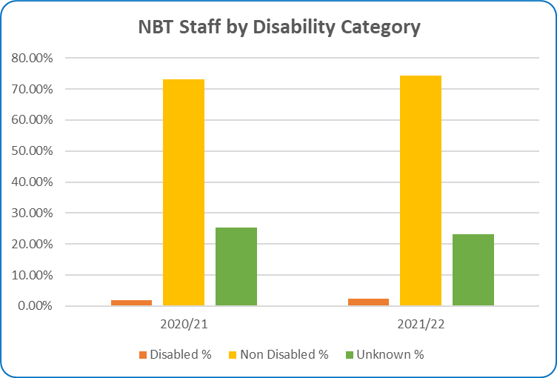
Chart: All NBT staff by disability category 2020/21 & 2021/22

Metric 1- Percentage of staff in AfC pay-bands or medical and dental subgroups and very senior managers (including Executive Board members) compared with the percentage of staff in the overall workforce.
There was an increase between 2020/21 and 2021/22 in staff at some grades identifying as having a disability, including bands 2,3,5,6,7,8b, all medical grades (except senior medical managers) and non-executive director level.

NBT Trust Wide

AFC 2020/21
Grade | Disabled % | Non Disabled % | Unknown %
Band 2 | 2.01% | 72.89% | 25.11%
Band 3 | 2.16% | 77.10% | 20.74%
Band 4 | 4.73% | 68.63% | 26.64%
Band 5 | 1.57% | 78.04% | 20.40%
Band 6 | 1.45% | 75.60% | 22.95%
Band 7 | 0.69% | 69.53% | 29.78%
Band 8a | 1.28% | 63.25% | 35.47%
Band 8b | 1.06% | 80.85% | 18.09%
Band 8c | 0.00% | 61.90% | 38.10%
Band 8d | 4.00% | 84.00% | 12.00%
Band 9 | 6.25% | 62.50% | 31.25%

Table: All NBT staff by disability category and job grade
Medical & Dental 2020/21
Consultant | 0.00% | 59.42% | 40.58%
Consultant - of Which SMM | 0.00% | 0.00% | 100.00%
Non-Consultant Career Grade | 1.79% | 55.36% | 42.86%
Trainee Grades | 0.27% | 65.15% | 34.58%

Table: All NBT staff by disability category and job grade
Exec 2020/21
VSM | 11.11% | 66.67% | 22.22%
Other | 0.60% | 85.03% | 14.37%
Total | 1.79% | 73.02% | 25.19%

Table: All NBT staff by disability category and job grade
AFC 2021/22
Grade | Disabled % | Non Disabled % | Unknown %
Band 2 | 3.20% | 73.77% | 23.03%
Band 3 | 2.81% | 76.65% | 20.54%
Band 4 | 2.64% | 73.49% | 23.87%
Band 5 | 1.74% | 77.04% | 21.21%
Band 6 | 1.94% | 77.33% | 20.73%
Band 7 | 1.93% | 71.14% | 26.93%
Band 8a | 1.17% | 64.84% | 33.98%
Band 8b | 3.92% | 78.43% | 17.65%
Band 8c | 0.00% | 76.00% | 24.00%
Band 8d | 0.00% | 85.19% | 14.81%
Band 9 | 5.88% | 64.71% | 29.41%

Table: All NBT staff by disability category and job grade
Medical & Dental 2021/22
Consultant | 0.80% | 61.52% | 37.68%
Consultant - of which SMM | 0.00% | 50.00% | 50.00%
Non Consultant Career Grade | 5.45% | 56.36% | 38.18%
Trainee Grades | 5.16% | 78.45% | 16.39%

Table: All NBT staff by disability category and job grade
Exec 2021/22
VSM | 0.00% | 88.89% | 11.11%
Non-Exec Director | 10.00% | 50.00% | 40.00%
Total | 2.44% | 74.37% | 23.19%

Table: All NBT staff by disability category and job grade

Metric 2 Relative likelihood of non-disabled staff compared to Disabled staff being appointed from shortlisting across all posts.
The relative likelihood of non-disabled staff being appointed after shortlisting compared to Disabled staff across all posts in 2021/22 was 1.18 this was a slight improvement from the 2020/21 figure of 1.38
Disability Status | Shortlisted | Appointed | % Appointed
No | 5293 | 1363 | 25.8%
Unknown/Not Stated | 135 | 55 | 40.7%
Yes | 496 | 108 | 21.8%
Total | 5924 | 1526 | 25.8%
Table: Number and Percentage of Staff appointed after shortlisting by disability status – 2021/22
Disability Status | Shortlisted | Appointed | % Appointed
No | 5344 | 1240 | 23.2%
Unknown/Not Stated | 255 | 165 | 64.7%
Yes | 346 | 58 | 16.8%
Table: Number and Percentage of Staff appointed after shortlisting by disability status – 2020/21

Metric 3 Relative likelihood of Disabled staff compared to non-disabled staff entering the formal capability process, as measured by entry into the formal capability procedure.
The Relative likelihood of Disabled staff entering the formal capability process compared to non-disabled staff, as measured by entry into the formal capability procedure for 2021/22 is 5.08, this is an improvement from 2020/21 when the figure was 7.09.
Financial Year | Disabled | Non Disabled | Unknown / Not Stated | Grand Total
Employees Entering Performance Assessment | 18 | 2 | 3 | 23
NBT Staff Total | 233 | 7097 | 2213 | 9543
Percentage of Staff Total in Performance Assessment | 7.73% | 0.03% | 0.14% | 0.24%
Table: Number and Percentage of Staff in formal capability process after shortlisting by disability status – 2021/22

Metric 4 - Harassment

a) Percentage of Disabled staff compared to non-disabled staff experiencing harassment, bullying or abuse from:

i. Patients/Service users, their relatives or other members of the public
Disability Category | 2018 | 2019 | 2020 | 2021
Staff with a LTC/ Illness - NBT | 32.7% | 32.4% | 33.2% | 32.7%
Staff without a LTC/Illness - NBT | 25.1% | 26.1% | 24.5% | 25.8%
Staff with a LTC/ Illness - National Average | 33.6% | 33.2% | 30.9% | 32.4%
Staff without a LTC/Illness - National Average | 26.6% | 26.5% | 24.5% | 25.2%
Table: staff experiencing harassment, bullying or abuse from patients/service users, their relatives or other members of the public.
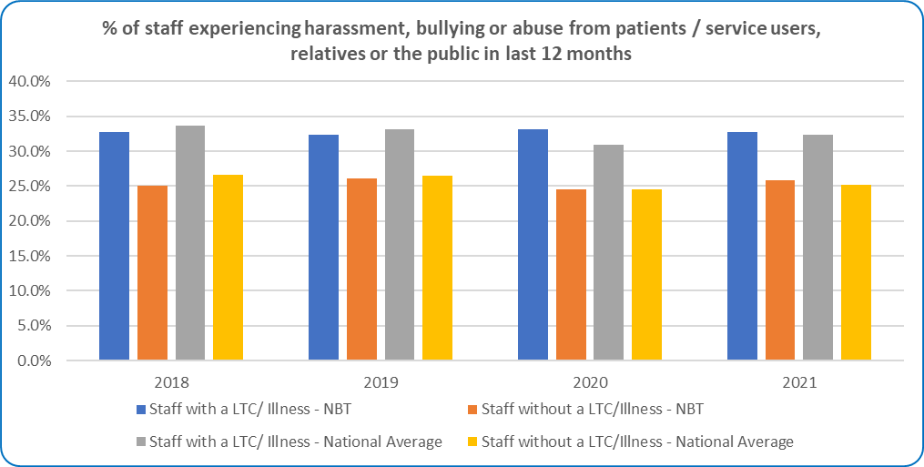
Chart: staff experiencing harassment, bullying or abuse from patients/service users, their relatives or other members of the public.

ii. Managers
Disability Category | 2018 | 2019 | 2020 | 2021
Staff with a LTC/ Illness - NBT | 20.0% | 16.8% | 15.9% | 13.9%
Staff without a LTC/Illness - NBT | 10.1% | 9.3% | 8.4% | 8.3%
Staff with a LTC/ Illness - National Average | 19.6% | 18.4% | 19.3% | 18.0%
Staff without a LTC/Illness - National Average | 11.7% | 10.8% | 10.8% | 9.8%
Table: staff experiencing harassment, bullying or abuse from Managers.

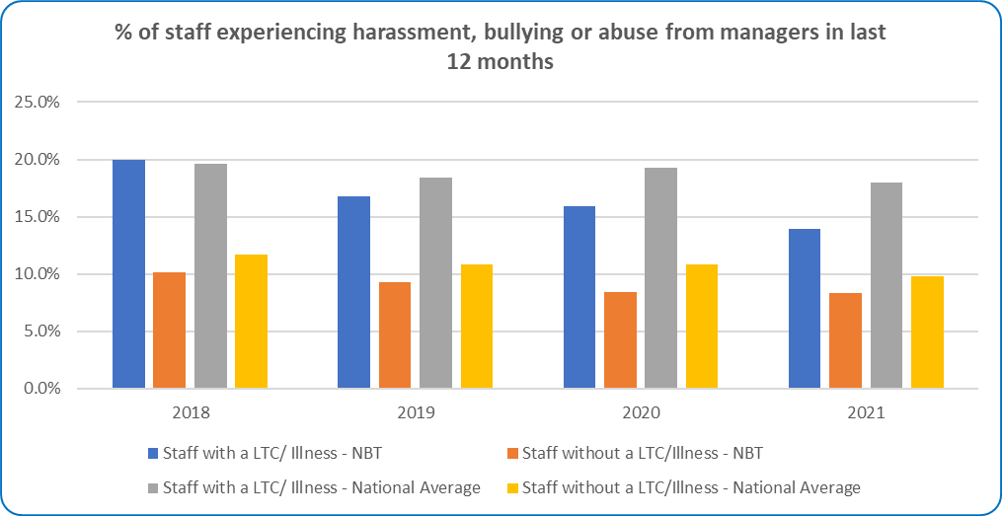
Chart: staff experiencing harassment, bullying or abuse from Managers.

iii. Other colleagues
Disability Category | 2018 | 2019 | 2020 | 2021
Staff with a LTC/ Illness - NBT | 29.4% | 28.3% | 27.4% | 27.1%
Staff without a LTC/Illness - NBT | 17.4% | 17.1% | 15.2% | 15.4%
Staff with a LTC/ Illness - National Average | 27.8% | 27.7% | 26.9% | 26.6%
Staff without a LTC/Illness - National Average | 18.0% | 17.5% | 17.8% | 17.1%
Table: staff experiencing harassment, bullying or abuse from other colleagues.

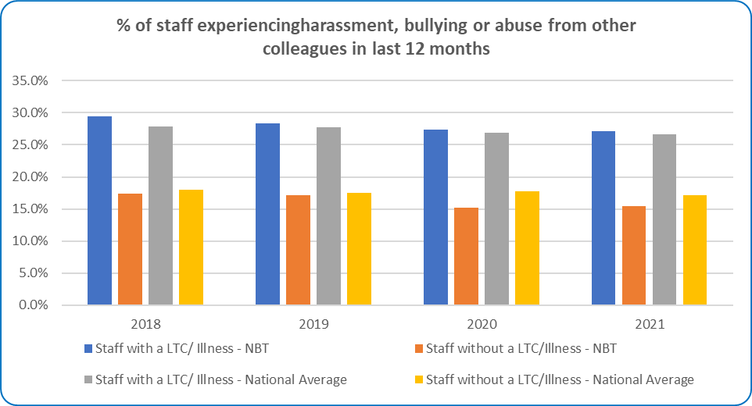
Chart: staff experiencing harassment, bullying or abuse from other colleagues.

b) Percentage of Disabled staff compared to non-disabled staff saying that the last time they experienced harassment, bullying or abuse at work, they or a colleague reported it
Disability Category | 2018 | 2019 | 2020 | 2021
Staff with a LTC/ Illness - NBT | 42.7% | 46.3% | 48.1% | 43.5%
Staff without a LTC/Illness - NBT | 41.3% | 45.0% | 46.7% | 42.5%
Staff with a LTC/ Illness - National Average | 45.4% | 46.9% | 47.0% | 47.0%
Staff without a LTC/Illness - National Average | 45.0% | 46.1% | 45.8% | 46.2%
Table: staff who experienced harassment, bullying or abuse from other colleagues and reported it.
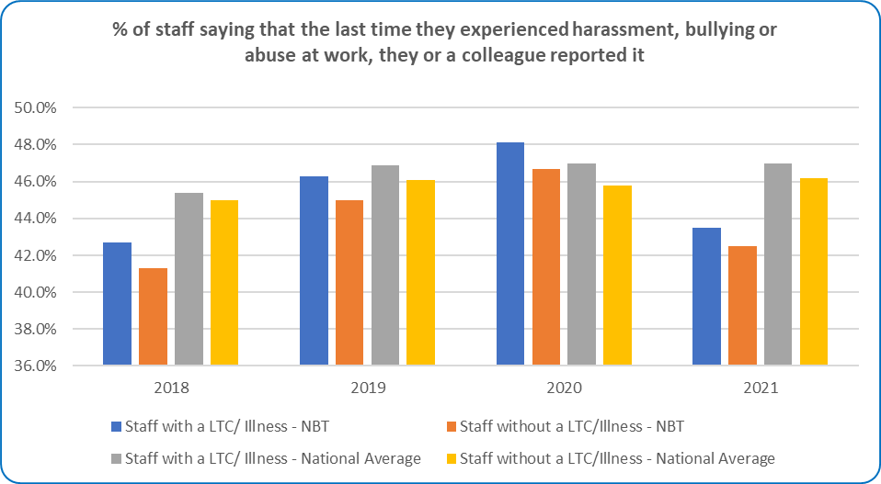
Chart: staff who experienced harassment, bullying or abuse from other colleagues and reported it.

Metric 5 - Percentage of Disabled staff compared to non-disabled staff believing that the Trust provides equal opportunities for career progression or promotion.
Disability Category | 2018 | 2019 | 2020 | 2021
Staff with a LTC/ Illness - NBT | 46.5% | 56.0% | 52.6% | 51.6%
Staff without a LTC/Illness - NBT | 56.0% | 58.4% | 57.3% | 57.1%
Staff with a LTC/ Illness - National Average | 51.3% | 51.9% | 51.6% | 51.4%
Staff without a LTC/Illness - National Average | 57.4% | 58.4% | 57.4% | 56.8%
Table: Percentage of staff who believe that their organisation provides equal opportunities for career progression or promotion
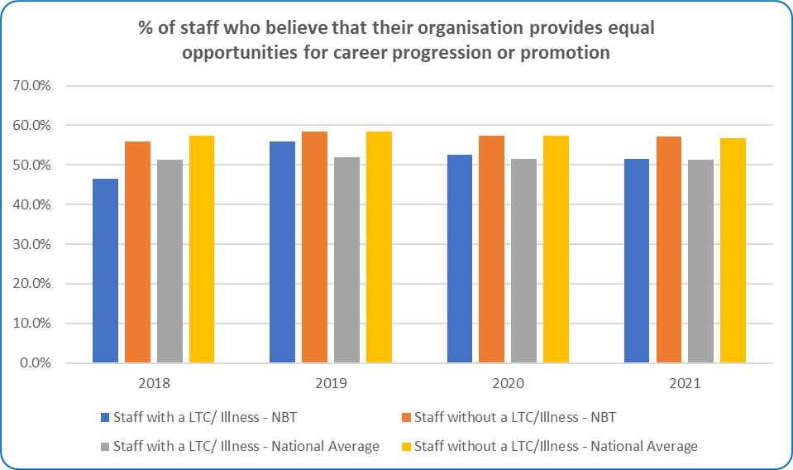
Chart: Percentage of staff who believe that their organisation provides equal opportunities for career progression or promotion

Metric 6 - Percentage of Disabled staff compared to non-disabled staff saying that they have felt pressure from their manager to come to work, despite not feeling well enough to perform their duties.
Disability Category | 2018 | 2019 | 2020 | 2021
Staff with a LTC/ Illness - NBT | 34.3% | 29.6% | 29.8% | 27.2%
Staff without a LTC/Illness - NBT | 24.8% | 19.3% | 21.7% | 21.0%
Staff with a LTC/ Illness - National Average | 33.3% | 32.7% | 33.0% | 32.2%
Staff without a LTC/Illness - National Average | 22.8% | 21.8% | 23.4% | 23.7%
Table: Metric 6 Percentage of Disabled staff compared to non-disabled staff saying that they have felt pressure from their manager to come to work, despite not feeling well enough to perform their duties

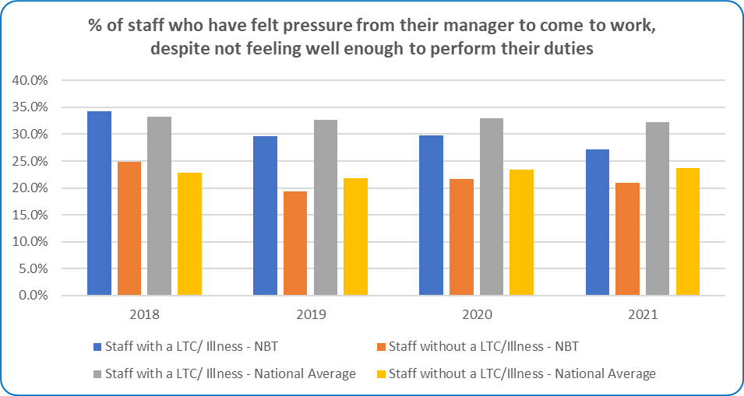
Chart: Metric 6 Percentage of Disabled staff compared to non-disabled staff saying that they have felt pressure from their manager to come to work, despite not feeling well enough to perform their duties

Metric 7 - Percentage of Disabled staff compared to non-disabled staff saying that they are satisfied with the extent to which their organisation values their work.
Disability Category | 2018 | 2019 | 2020 | 2021
Staff with a LTC/ Illness - NBT | 31.1% | 39.0% | 38.6% | 30.0%
Staff without a LTC/Illness - NBT | 43.7% | 49.1% | 49.2% | 43.4%
Staff with a LTC/ Illness - National Average | 36.8% | 38.1% | 37.4% | 32.6%
Staff without a LTC/Illness - National Average | 47.9% | 49.9% | 49.3% | 43.3%
Table: Metric 7 Satisfaction with the extent to which their organisation values their work

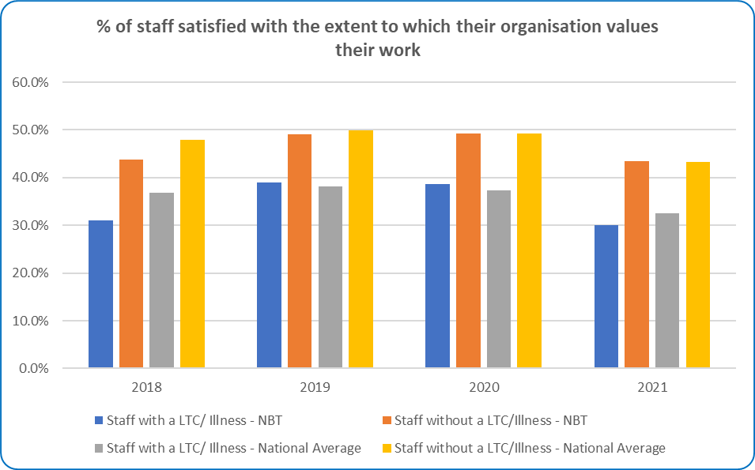
Chart: Metric 7 Satisfaction with the extent to which their organisation values their work

Metric 8 - Percentage of Disabled staff saying that their employer has made adequate adjustment(s) to enable them to carry out their work.
Disability Category | 2018 | 2019 | 2020 | 2021
Staff with a LTC/ Illness - NBT | 69.6% | 75.8% | 78.1% | 71.1%
Staff with a LTC/ Illness - National Average | 73.1% | 73.3% | 75.5% | 70.9%
Table: Metric 8 Adequate Adjustments for disabled staff NBT & National
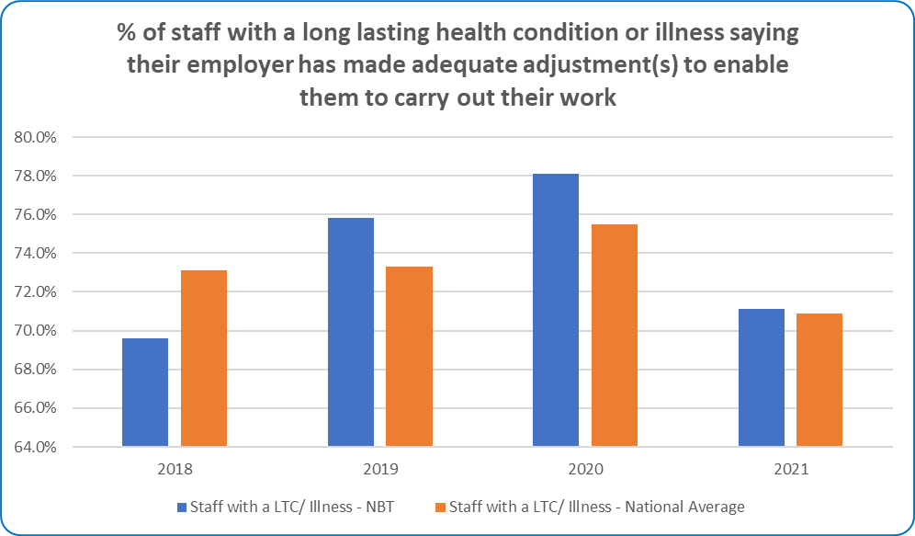
Chart: Metric 8 Adequate Adjustments for disabled staff NBT & National

Metric 9 – Engagement

a) The staff engagement score for Disabled staff, compared to non-disabled staff.
Staff engagement score (0-10)
Disability Category | 2018 | 2019 | 2020 | 2021
Staff with a LTC/ Illness - NBT | 6.4 | 6.8 | 6.8 | 6.5
Staff without a LTC/Illness - NBT | 7.0 | 7.2 | 7.2 | 7.0
Staff with a LTC/ Illness - National Average | 6.6 | 6.7 | 6.7 | 6.4
Staff without a LTC/Illness - National Average | 7.1 | 7.1 | 7.1 | 7.0
Table: Staff Engagement Score (0-10) Average Score by Disability Category
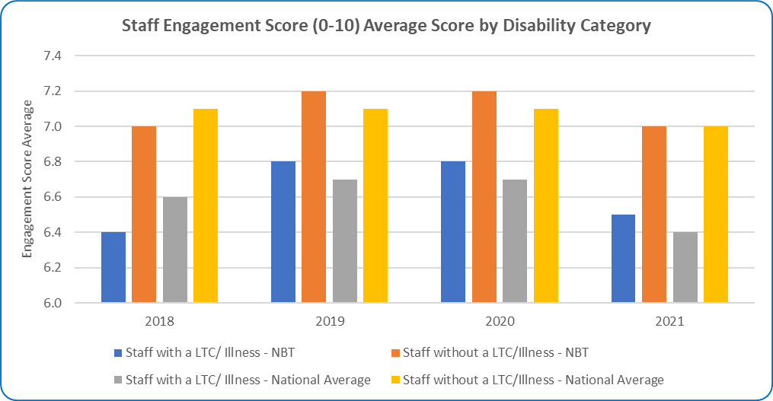
Chart: Staff Engagement Score (0-10) Average Score by Disability Category

b) Has your Trust taken action to facilitate the voices of Disabled staff in your organisation to be heard?

Yes

Disabled/Neurodiverse staff have their own WhatsApp Groups to share information in addition to direct emails. Disabled/Neurodiverse staff contributed to the development of various initiatives including the development of the MY Appraisal framework, where direct feedback from consultation at a staff network meeting was used to amend the draft template and to provide guidance and signposting to reasonable adjustment passports. Disabled/Neurodiverse staff have been invited to be involved in helping a range of activities, with a small number of volunteers helping to organise activities for events such as
a. International Autism Awareness Week
b. Mental Health Awareness Week Theme: Kindness?
c. NHS Equality and Human Rights Week
d. World Mental Health Day
e. Disability History Month Starts
f. World AIDS Day
g. International Day for Disabled People

Metric 10 - Percentage difference between the organisation’s Board voting membership and its organisation’s overall workforce, disaggregated:
Disability Category | Non-voting | Voting | Board Total
Yes |  | 1 | 1
No | 3 | 9 | 12
Not Declared/ Prefer not to Answer | 2 | 3 | 5
Grand Total | 5 | 13 | 18
Table: NBT Board Members by disability category and voting rights – 2021/22

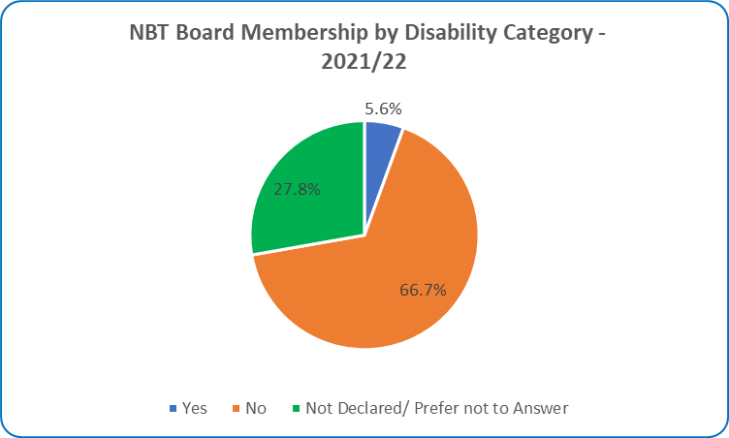
Chart: NBT Board Members by disability category– 2021/22

Disability Category | Non-voting | Voting | Board Total
Disabled | 0 | 2 | 2
Non Disabled | 3 | 7 | 10
Not Declared/ Prefer not to Answer | 2 | 3 | 5
Grand Total | 5 | 12 | 17
Table: NBT Board Members by disability category and voting rights – 2020/21
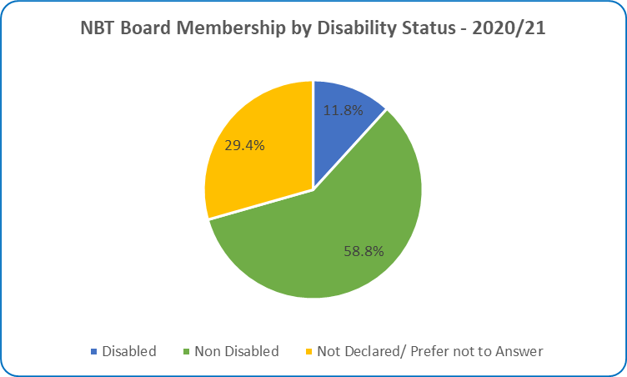
Chart: NBT Board Members by disability category– 2020/21

NBT Staff Disability Category and Group
There was an increase in staff identifying as having a disability between 2020/21 and 2021/22 across the majority of staff groups.

2020/21
Staff Group | Disabled | Non Disabled | Unknown
Add Prof Scientific and Technic | 1.00% | 78.26% | 20.74%
Additional Clinical Services | 1.98% | 77.56% | 20.46%
Administrative and Clerical | 2.89% | 76.64% | 20.46%
Allied Health Professionals | 3.61% | 70.59% | 25.81%
Estates and Ancillary | 1.40% | 64.53% | 34.07%
Healthcare Scientists | 0.24% | 67.48% | 32.28%
Medical and Dental | 0.28% | 64.91% | 34.81%
Nursing and Midwifery Registered | 0.82% | 75.07% | 24.11%
Students | 28.57% | 37.14% | 34.29%
Total | 1.79% | 73.02% | 25.19%

Table: All NBT staff by disability category and Staff Group – 2020/21 & 2021/22
2021/22
Staff Group | Disabled | Non Disabled | Unknown
Add Prof Scientific and Technic | 2.40% | 76.00% | 21.60%
Additional Clinical Services | 1.75% | 79.64% | 18.61%
Administrative and Clerical | 4.43% | 76.55% | 19.01%
Allied Health Professionals | 4.08% | 72.62% | 23.30%
Estates and Ancillary | 2.06% | 65.86% | 32.08%
Healthcare Scientists | 1.79% | 69.35% | 28.86%
Medical and Dental | 3.18% | 69.57% | 27.25%
Nursing and Midwifery Registered | 0.97% | 74.90% | 24.13%
Students | 0.00% | 90.91% | 9.09%
Total | 2.44% | 74.37% | 23.19%

Table: All NBT staff by disability category and Staff Group – 2020/21 & 2021/22

Division Views

Anaesthesia, Surgery, Critical & Renal Division

2020/21
Grade | Disabled % | Non Disabled % | Unknown %
Band 2 | 3.72% | 75.81% | 20.47%
Band 3 | 2.25% | 76.58% | 21.17%
Band 4 | 1.73% | 73.41% | 24.86%
Band 5 | 1.31% | 74.39% | 24.31%
Band 6 | 1.10% | 75.46% | 23.44%
Band 7 | 0.00% | 77.19% | 22.81%
Band 8a | 0.00% | 68.75% | 31.25%
Band 8b | 0.00% | 75.00% | 25.00%
Band 8c | 0.00% | 0.00% | 100.00%
Band 8d | 0.00% | 100.00% | 0.00%
Band 9 | 0.00% | 100.00% | 0.00%
Consultant | 0.00% | 51.67% | 48.33%
Consultant - of which SMM | 0.00% | 0.00% | 100.00%
Non-Consultant Career Grade | 3.70% | 59.26% | 37.04%
Other | 0.00% | 100.00% | 0.00%
Trainee Grades | 0.00% | 71.54% | 28.46%
Total | 1.38% | 73.16% | 25.46%

Table: Anaesthesia, Surgery, Critical & Renal Division staff by disability category and job grade

2021/22
Grade | Disabled % | Non Disabled % | Unknown %
Band 2 | 6.38% | 74.47% | 19.15%
Band 3 | 3.54% | 76.11% | 20.35%
Band 4 | 2.40% | 79.04% | 18.56%
Band 5 | 0.82% | 72.62% | 26.56%
Band 6 | 1.86% | 72.12% | 26.02%
Band 7 | 1.43% | 75.00% | 23.57%
Band 8a | 0.00% | 77.27% | 22.73%
Band 8b | 0.00% | 80.00% | 20.00%
Band 8c | 0.00% | 0.00% | 100.00%
Band 8d | 0.00% | 100.00% | 0.00%
Band 9 | 0.00% | 100.00% | 0.00%
Consultant | 0.52% | 56.48% | 43.01%
Consultant - of which SMM | 0.00% | 0.00% | 100.00%
Non Consultant Career Grade | 4.55% | 63.64% | 31.82%
Trainee Grades | 1.60% | 87.77% | 10.64%
Total | 2.01% | 73.61% | 24.37%

Table: Anaesthesia, Surgery, Critical & Renal Division staff by disability category and job grade

Core Clinical Services

2020/21
Grade | Disabled % | Non Disabled % | Unknown %
Band 2 | 6.06% | 75.42% | 18.52%
Band 3 | 2.53% | 76.17% | 21.30%
Band 4 | 1.36% | 73.47% | 25.17%
Band 5 | 2.36% | 80.31% | 17.32%
Band 6 | 2.08% | 73.44% | 24.48%
Band 7 | 0.44% | 59.11% | 40.44%
Band 8a | 0.00% | 48.00% | 52.00%
Band 8b | 0.00% | 69.23% | 30.77%
Band 8c | 0.00% | 50.00% | 50.00%
Band 8d | 0.00% | 60.00% | 40.00%
Band 9 | 33.33% | 66.67% | 0.00%
Consultant | 0.00% | 67.12% | 32.88%
Non-Consultant Career Grade | 0.00% | 100.00% | 0.00%
Other | 0.00% | 100.00% | 0.00%
Trainee Grades | 0.00% | 56.52% | 43.48%
Total | 2.37% | 71.65% | 25.98%

Table: Core Clinical Services Division staff by disability category and job grade
2021/22
Grade | Disabled % | Non Disabled % | Unknown %
Band 2 | 6.09% | 78.85% | 15.05%
Band 3 | 2.32% | 76.45% | 21.24%
Band 4 | 1.99% | 71.52% | 26.49%
Band 5 | 2.53% | 82.28% | 15.19%
Band 6 | 2.75% | 75.75% | 21.50%
Band 7 | 2.16% | 58.62% | 39.22%
Band 8a | 1.22% | 51.22% | 47.56%
Band 8b | 0.00% | 65.52% | 34.48%
Band 8c | 0.00% | 63.16% | 36.84%
Band 8d | 0.00% | 75.00% | 25.00%
Band 9 | 33.33% | 33.33% | 33.33%
Consultant | 0.00% | 70.27% | 29.73%
Non Consultant Career Grade | 0.00% | 100.00% | 0.00%
Trainee Grades | 0.00% | 66.67% | 33.33%
Total | 2.78% | 72.79% | 24.43%

Table: Core Clinical Services Division staff by disability category and job grade

Medicine Division

2020/21
Grade | Disabled % | Non Disabled % | Unknown %
Band 2 | 0.78% | 78.13% | 21.09%
Band 3 | 0.58% | 79.07% | 20.35%
Band 4 | 7.33% | 64.67% | 28.00%
Band 5 | 0.22% | 78.79% | 21.00%
Band 6 | 1.18% | 73.96% | 24.85%
Band 7 | 0.00% | 74.34% | 25.66%
Band 8a | 4.76% | 71.43% | 23.81%
Band 8b | 0.00% | 85.71% | 14.29%
Band 8c | 0.00% | 50.00% | 50.00%
Band 8d | 0.00% | 100.00% | 0.00%
Band 9 | 0.00% | 100.00% | 0.00%
Consultant | 0.00% | 78.43% | 21.57%
Consultant - of which SMM | 0.00% | 0.00% | 100.00%
Non-Consultant Career Grade | 0.00% | 50.00% | 50.00%
Other | 0.00% | 82.76% | 17.24%
Trainee Grades | 0.00% | 53.85% | 46.15%
Total | 1.06% | 75.07% | 23.87%

Table: Medicine Division staff by disability category and job grade
2021/22
Grade | Disabled % | Non Disabled % | Unknown %
Band 2 | 2.31% | 77.23% | 20.46%
Band 3 | 1.15% | 80.46% | 18.39%
Band 4 | 1.85% | 68.52% | 29.63%
Band 5 | 0.66% | 76.64% | 22.71%
Band 6 | 0.94% | 77.46% | 21.60%
Band 7 | 1.25% | 78.75% | 20.00%
Band 8a | 0.00% | 80.00% | 20.00%
Band 8b | 0.00% | 85.71% | 14.29%
Band 8c | 0.00% | 66.67% | 33.33%
Band 8d | 0.00% | 0.00% | 100.00%
Band 9 | 0.00% | 100.00% | 0.00%
Consultant | 0.95% | 74.29% | 24.76%
Consultant - of which SMM | 0.00% | 0.00% | 100.00%
Non Consultant Career Grade | 9.52% | 52.38% | 38.10%
Trainee Grades | 0.66% | 83.55% | 15.79%
Total | 1.30% | 77.08% | 21.63%

Table: Medicine Division staff by disability category and job grade

Neurosciences & Musculoskeletal Division

2020/21
Grade | Disabled % | Non Disabled % | Unknown %
Band 2 | 0.00% | 80.00% | 20.00%
Band 3 | 4.82% | 71.69% | 23.49%
Band 4 | 8.72% | 62.42% | 28.86%
Band 5 | 2.04% | 78.57% | 19.39%
Band 6 | 2.13% | 73.40% | 24.47%
Band 7 | 1.60% | 66.40% | 32.00%
Band 8a | 3.45% | 62.07% | 34.48%
Band 8b | 0.00% | 90.00% | 10.00%
Band 8c | 0.00% | 60.00% | 40.00%
Band 8d | 0.00% | 100.00% | 0.00%
Band 9 | 0.00% | 50.00% | 50.00%
Consultant | 0.00% | 49.45% | 50.55%
Non-Consultant Career Grade | 0.00% | 60.00% | 40.00%
Other | 2.70% | 75.68% | 21.62%
Trainee Grades | 1.41% | 64.79% | 33.80%
Total | 2.79% | 70.23% | 26.98%

Table: Neurosciences & Musculoskeletal Division staff by disability category and job grade

2021/22
Grade | Disabled % | Non Disabled % | Unknown %
Band 2 | 2.38% | 80.95% | 16.67%
Band 3 | 4.49% | 71.15% | 24.36%
Band 4 | 2.29% | 71.76% | 25.95%
Band 5 | 2.62% | 76.96% | 20.42%
Band 6 | 4.35% | 72.83% | 22.83%
Band 7 | 3.03% | 66.67% | 30.30%
Band 8a | 0.00% | 57.69% | 42.31%
Band 8b | 8.33% | 91.67% | 0.00%
Band 8c | 0.00% | 75.00% | 25.00%
Band 8d | 0.00% | 100.00% | 0.00%
Band 9 | 0.00% | 0.00% | 100.00%
Consultant | 2.25% | 50.56% | 47.19%
Non-Consultant Career Grade | 0.00% | 60.00% | 40.00%
Trainee Grades | 10.42% | 69.79% | 19.79%
Total | 3.61% | 71.42% | 24.98%

Table: Neurosciences & Musculoskeletal Division staff by disability category and job grade

Women’s and Children’s Health

2020/21
Grade | Disabled % | Non Disabled % | Unknown %
Band 2 | 0.00% | 75.34% | 24.66%
Band 3 | 0.00% | 76.19% | 23.81%
Band 4 | 10.26% | 64.10% | 25.64%
Band 5 | 3.08% | 80.77% | 16.15%
Band 6 | 0.41% | 78.86% | 20.73%
Band 7 | 0.00% | 65.88% | 34.12%
Band 8a | 0.00% | 60.00% | 40.00%
Band 8b | 0.00% | 60.00% | 40.00%
Band 9 | 0.00% | 0.00% | 100.00%
Consultant | 0.00% | 55.88% | 44.12%
Non-Consultant Career Grade | 0.00% | 25.00% | 75.00%
Other | 0.00% | 75.00% | 25.00%
Trainee Grades | 0.00% | 73.17% | 26.83%
Total | 1.11% | 74.13% | 24.75%

Table: Women’s and Children’s Health Division staff by disability category and job grade

2021/22
Grade | Disabled % | Non Disabled % | Unknown %
Band 2 | 0.00% | 79.10% | 20.90%
Band 3 | 0.00% | 78.74% | 21.26%
Band 4 | 0.00% | 70.97% | 29.03%
Band 5 | 3.08% | 83.85% | 13.08%
Band 6 | 1.26% | 81.93% | 16.81%
Band 7 | 0.00% | 70.11% | 29.89%
Band 8a | 0.00% | 65.00% | 35.00%
Band 8b | 0.00% | 80.00% | 20.00%
Band 8c | 0.00% | 0.00% | 100.00%
Band 8d | 0.00% | 100.00% | 0.00%
Band 9 | 0.00% | 100.00% | 0.00%
Consultant | 0.00% | 60.00% | 40.00%
Non Consultant Career Grade | 0.00% | 20.00% | 80.00%
Trainee Grades | 22.22% | 60.00% | 17.78%
Total | 2.14% | 76.67% | 21.19%

Table: Women’s and Children’s Health Division staff by disability category and job grade

Facilities

2020/21
Grade | Disabled % | Non Disabled % | Unknown %
Band 2 | 1.20% | 65.57% | 33.23%
Band 3 | 3.37% | 69.66% | 26.97%
Band 4 | 1.72% | 62.07% | 36.21%
Band 5 | 4.55% | 63.64% | 31.82%
Band 6 | 0.00% | 66.67% | 33.33%
Band 7 | 0.00% | 71.43% | 28.57%
Band 8a | 0.00% | 50.00% | 50.00%
Band 8b | 0.00% | 100.00% | 0.00%
Band 8c | 0.00% | 75.00% | 25.00%
Band 8d | 0.00% | 100.00% | 0.00%
Band 9 | 0.00% | 0.00% | 100.00%
Total | 1.47% | 65.91% | 32.62%

Table: Facilities Division staff by disability category and job grade
2021/22
Grade | Disabled % | Non Disabled % | Unknown %
Band 2 | 1.83% | 67.38% | 30.79%
Band 3 | 4.49% | 73.03% | 22.47%
Band 4 | 3.39% | 59.32% | 37.29%
Band 5 | 4.35% | 65.22% | 30.43%
Band 6 | 0.00% | 78.57% | 21.43%
Band 7 | 0.00% | 72.22% | 27.78%
Band 8a | 0.00% | 50.00% | 50.00%
Band 8b | 0.00% | 100.00% | 0.00%
Band 8c | 0.00% | 75.00% | 25.00%
Band 8d | 0.00% | 100.00% | 0.00%
Total | 2.18% | 67.66% | 30.16%

Table: Facilities Division staff by disability category and job grade

Corporate Divisions

2020/21
Grade | Disabled % | Non Disabled % | Unknown %
Band 2 | 0.00% | 78.05% | 21.95%
Band 3 | 1.53% | 85.71% | 12.76%
Band 4 | 5.15% | 74.26% | 20.59%
Band 5 | 2.53% | 86.08% | 11.39%
Band 6 | 1.64% | 80.87% | 17.49%
Band 7 | 2.19% | 78.83% | 18.98%
Band 8a | 1.79% | 80.36% | 17.86%
Band 8b | 3.23% | 87.10% | 9.68%
Band 8c | 0.00% | 84.62% | 15.38%
Band 8d | 9.09% | 90.91% | 0.00%
Band 9 | 0.00% | 75.00% | 25.00%
Consultant | 0.00% | 0.00% | 100.00%
Trainee Grades | 0.00% | 50.00% | 50.00%
VSM | 0.00% | 100.00% | 0.00%
Other | 0.00% | 37.50% | 62.50%
Total | 2.35% | 81.21% | 16.45%

Table: NBT Corporate Division staff by disability category and job grade
2021/22
Grade | Disabled % | Non Disabled % | Unknown %
Band 2 | 6.67% | 71.11% | 22.22%
Band 3 | 3.87% | 79.01% | 17.13%
Band 4 | 4.70% | 80.54% | 14.77%
Band 5 | 4.32% | 82.70% | 12.97%
Band 6 | 1.36% | 83.26% | 15.38%
Band 7 | 3.07% | 82.21% | 14.72%
Band 8a | 2.50% | 75.00% | 22.50%
Band 8b | 8.11% | 81.08% | 10.81%
Band 8c | 0.00% | 100.00% | 0.00%
Band 8d | 0.00% | 85.71% | 14.29%
Band 9 | 0.00% | 77.78% | 22.22%
Consultant | 0.00% | 66.67% | 33.33%
Consultant - of which SMM | 0.00% | 100.00% | 0.00%
Trainee Grades | 12.50% | 62.50% | 25.00%
VSM | 0.00% | 88.89% | 11.11%
Non-Exec Director | 10.00% | 50.00% | 40.00%
Total | 3.71% | 80.31% | 15.98%

Table: NBT Corporate Division staff by disability category and job grade

