# NBT WRES REPORT 2022

All data is for the NBT position as 31 March 2022, with all permanent, fixed term contract and non-executive directors included.

## NBT Workforce Composition

|  |  |  |  |  |  |  |  |
| --- | --- | --- | --- | --- | --- | --- | --- |
| **Financial Year** | **White Head Count** | **White %** | **BAME Head Count** | **BAME %** | **Unknown/Not Stated Head Count** | **Unknown/Not Stated %** | **NBT Total** |
| **2020/21** | 7597 | 79.31% | 1642 | 17.14% | 340 | 3.55% | 9579 |
| **2021/22** | 7264 | 76.12% | 1872 | 19.62% | 407 | 4.26% | 9543 |

*Table: ALL NBT Staff by Ethnicity Grouping, Head Count & Percentage – 2020/21 & 2021/22*

*Chart: ALL NBT Staff by Ethnicity Grouping, Head Count & Percentage – 2020/21 & 2021/22*

NBT saw an increase in the proportion of staff from BAME backgrounds (an increase of 2.47% or 230 headcount) .

## Indicator 1 Percentage of Staff in each of the AfC Bands 1-9 or Medical and Dental subgroups and VSM (including Executive Board Members) compared with the percentage of staff in the overall workforce.

There has been an increase in the proportion of NBT staff who identify as being from BAME backgrounds from 2020/21 to 2021/22, this is the case in both clinical and non-clinical roles. This improvement was seen in key groups such as clinical band 5 and 6 roles, which make up the bulk of the NBT staff population. However there was a more mixed picture for roles in bands 7 and above, with increases in the proportion of people from BAME backgrounds in bands 7 and 8a, but decreases in band 8b and higher.

## Proportion of Staff in Band 7 or Higher by Ethnicity Grouping

|  |  |  |  |  |
| --- | --- | --- | --- | --- |
| Band Category | BAME | Unknown/ No Stated | White | Grand Total |
| Clinical | 20.79% | 5.10% | 74.11% | 100.00% |
| Below Band 7 | 24.59% | 3.11% | 72.29% | 100.00% |
| Band 7 & 8a | 7.00% | 0.86% | 92.13% | 100.00% |
| 8b or Higher | 2.60% | 0.00% | 97.40% | 100.00% |
| Medical & Dental / Non AFC | 17.21% | 17.57% | 65.23% | 100.00% |
| Non-Clinical | 16.54% | 2.08% | 81.38% | 100.00% |
| Below Band 7 | 18.19% | 2.05% | 79.76% | 100.00% |
| Band 7 & 8a | 8.56% | 1.17% | 90.27% | 100.00% |
| 8b or Higher | 4.20% | 2.52% | 93.28% | 100.00% |
| Medical & Dental / Non AFC | 5.56% | 16.67% | 77.78% | 100.00% |
| **Grand Total** | **19.62%** | **4.26%** | **76.12%** | **100.00%** |

*Table: ALL NBT Staff - Proportion of Staff in Band 8b or Higher by Ethnicity Grouping – 2021/22*

|  |  |  |  |  |
| --- | --- | --- | --- | --- |
| Band Category | BAME | Unknown/ No Stated | White | Grand Total |
| Clinical | 17.88% | 4.26% | 77.87% | 100.00% |
| Below Band 7 | 20.08% | 2.30% | 77.62% | 100.00% |
| Band 7 & 8a | 6.36% | 0.69% | 92.95% | 100.00% |
| 8b or Higher | 3.17% | 0.00% | 96.83% | 100.00% |
| Medical & Dental / Non AFC | 17.86% | 16.21% | 65.93% | 100.00% |
| Non-Clinical | 15.16% | 1.65% | 83.19% | 100.00% |
| Below Band 7 | 16.79% | 1.53% | 81.69% | 100.00% |
| Band 7 & 8a | 6.67% | 0.83% | 92.50% | 100.00% |
| 8b or Higher | 3.51% | 2.63% | 93.86% | 100.00% |
| Medical & Dental / Non AFC | 0.00% | 23.53% | 76.47% | 100.00% |
| **Grand Total** | **17.14%** | **3.55%** | **79.31%** | **100.00%** |

*Table: ALL NBT Staff - Proportion of Staff in Band 8b or Higher by Ethnicity Grouping – 2020/21*

## 2 Relative likelihood of BAME staff being appointed from shortlisting.

The relative likelihood of White staff being appointed from shortlisting compared to BME staff for 2021/22 was **1.33**, this is an improvement from the 2020/21 figure of **1.46**.

|  |  |  |  |
| --- | --- | --- | --- |
| **Row Labels** | **Sum of Shortlisted** | **Sum of Appointed** | **Likelihood of appointment after shortlisting** |
| BAME | 1738 | 358 | 21% |
| Unknown/Not Stated | 153 | 40 | 26% |
| White | 4033 | 1128 | 28% |
| **Grand Total** | **5924** | **1526** | **26%** |

*Table: 2021/22 ALL NBT Staff Recruitment Success Rates*

## 3 Relative likelihood of staff entering into a formal disciplinary process.

The relative likelihood of what BAME staff entering into a formal disciplinary process compared to white staff in 2021/22 was **1.49**, a slight increase from 1.44 in 2020/21.

|  |  |  |  |  |
| --- | --- | --- | --- | --- |
|  | **White** | **BAME** | **Not Stated** | **Total** |
| All Staff Head Count | 7264 | 1872 | 407 | 9543 |
| Number of staff entering formal disciplinary process | 13 | 5 | 0 | 18 |

*Table: 2021/22 ALL NBT Staff and number of formal disciplinary process cases*

|  |  |  |  |  |
| --- | --- | --- | --- | --- |
|  | **White** | **BAME** | **Not Stated** | **Total** |
| All Staff Head Count | 7597 | 1642 | 340 | 9579 |
| Number of staff entering formal disciplinary process | 10 | 3 | 0 | 13 |

*Table: 2020/21 ALL NBT Staff and number of formal disciplinary process cases*

## 4 Relative likelihood of staff accessing non-mandatory training and CPD.

The relative likelihood of white staff accessing non-mandatory training and CPD compared to BAME staff in 2021/22 is **1.46,** this is an increase from 1.42 in 2020/21.

|  |  |  |
| --- | --- | --- |
| **Ethnicity Category** | **CPD Participant Count** | **% of ethnic group accessing CPD** |
| BME | 55 | 2.94% |
| Not Stated | 16 | 3.93% |
| White | 311 | 4.28% |

*Table: 2021/22 Non- mandatory CPD participation*

## Indicators 5 to 8 National Staff Survey Results

## 5 Percentage of staff experiencing harassment, bullying or abuse from patients, relatives or the public in the last 12 months

|  |  |  |  |  |  |
| --- | --- | --- | --- | --- | --- |
| **Ethnicity Category** | **2017** | **2018** | **2019** | **2020** | **2021** |
| White - NBT | 27.7% | 26.6% | 27.3% | 26.3% | 27.8% |
| BAME - NBT | 21.5% | 24.7% | 26.5% | 25.1% | 25.0% |
| White - National Average | 27.1% | 27.1% | 27.7% | 25.4% | 26.5% |
| BAME - National Average | 27.5% | 28.8% | 29.5% | 28.0% | 28.8% |

*Table: Percentage of Percentage of staff experiencing harassment, bullying or abuse from patients, relatives or the public in the last 12 months 2017-2021*

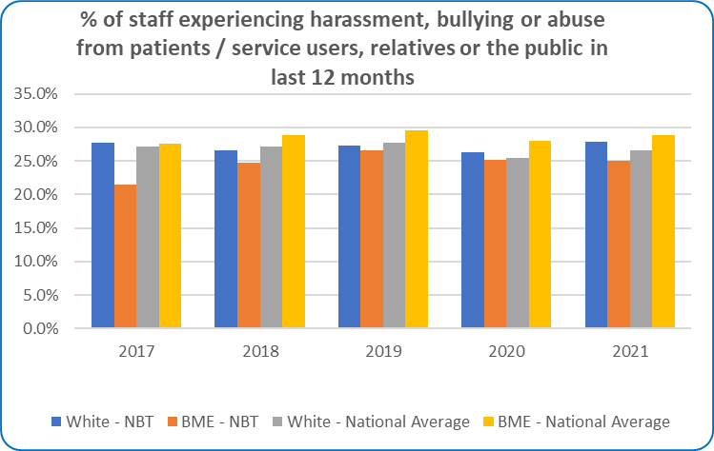

*Chart: Percentage of Percentage of staff experiencing harassment, bullying or abuse from patients, relatives or the public in the last 12 months 2017-2021*

## 6 Percentage of staff experiencing harassment, bullying or abuse from staff in the last 12 months

|  |  |  |  |  |  |
| --- | --- | --- | --- | --- | --- |
| **Ethnicity Category** | **2017** | **2018** | **2019** | **2020** | **2021** |
| White - NBT | 24.8% | 25.1% | 24.0% | 21.9% | 22.3% |
| BME - NBT | 26.3% | 26.9% | 24.6% | 25.7% | 25.1% |
| White - National Average | 23.9% | 25.0% | 24.4% | 24.4% | 23.6% |
| BME - National Average | 27.6% | 28.7% | 28.4% | 29.1% | 28.5% |

*Table: Percentage of staff experiencing harassment, bullying or abuse from staff in the last 12 months 2017-2021*

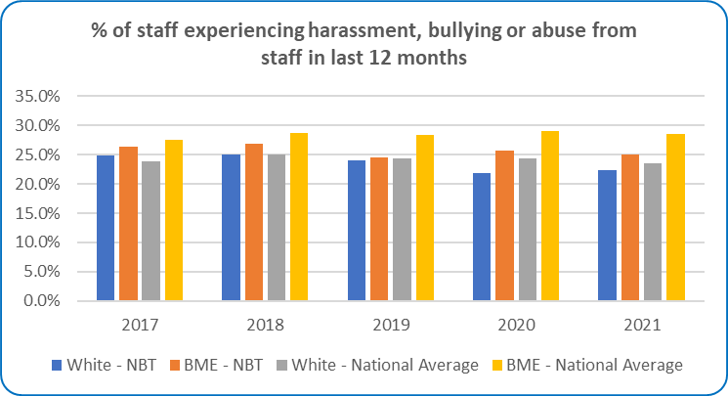

*Chart: Percentage of staff experiencing harassment, bullying or abuse from staff in the last 12 months 2017-2021*

## 7 Percentage believing the Trust provides equal opportunities for career progression or promotion

|  |  |  |  |  |  |
| --- | --- | --- | --- | --- | --- |
| **Ethnicity Category** | **2017** | **2018** | **2019** | **2020** | **2021** |
| White - NBT | 58.6% | 56.7% | 60.9% | 59.2% | 58.7% |
| BME - NBT | 42.4% | 37.6% | 42.3% | 41.2% | 40.5% |
| White - National Average | 61.0% | 59.0% | 60.0% | 59.4% | 58.6% |
| BME - National Average | 48.8% | 46.4% | 46.6% | 45.2% | 44.6% |

*Table: Percentage of staff believing the Trust provides equal opportunities for career progression or promotion 2017-2021*

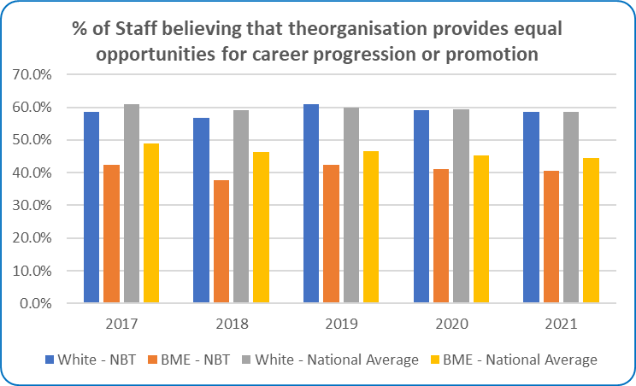

*Chart: Percentage of staff believing the Trust provides equal opportunities for career progression or promotion 2017-2021*

## 8 Percentage of staff personally experiencing discrimination at work from a manager

|  |  |  |  |  |  |
| --- | --- | --- | --- | --- | --- |
| **Ethnicity Category** | **2017** | **2018** | **2019** | **2020** | **2021** |
| White - NBT | 6.3% | 6.3% | 5.7% | 5.9% | 6.4% |
| BME - NBT | 15.2% | 17.1% | 12.0% | 17.6% | 16.2% |
| White - National Average | 6.6% | 6.3% | 5.9% | 6.1% | 6.7% |
| BME - National Average | 14.9% | 14.6% | 14.1% | 16.8% | 17.3% |

*Table: Percentage of staff personally experiencing discrimination at work from a manager 2017-2021*

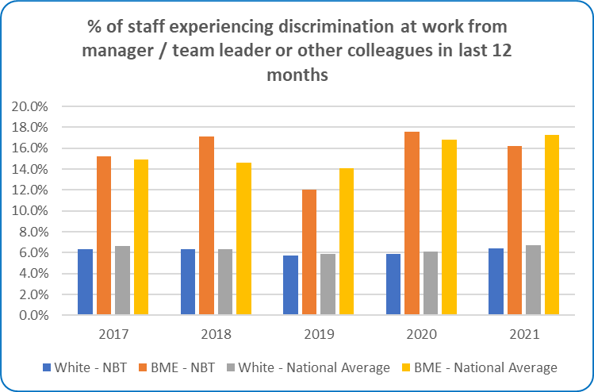

*Chart: Percentage of staff personally experiencing discrimination at work from a manager 2017-2021*

## Indicator 9 – Board representation indicator - difference between white and BME staff.

There was an increase in the number of board members who identified as being from a BAME background from 0 in 2021 to 1 in 2022; this person does not hold voting rights on the board.

|  |  |  |  |
| --- | --- | --- | --- |
| Ethnicity Grouping | Non-voting | Voting | Total |
| BAME | 1 |  | 1 |
| Not Stated | 1 | 2 | 3 |
| White | 3 | 11 | 14 |
| **Total** | **5** | **13** | **18** |

*Table: NBT Board Members by Ethnic Grouping and Board Voting Rights as at 31 March 2022*

|  |  |  |  |
| --- | --- | --- | --- |
| Ethnicity Grouping | Non-voting | Voting | Total |
| BAME | 0 | 0 | 0 |
| Not Stated | 2 | 2 | 4 |
| White | 3 | 10 | 13 |
| **Total** | **5** | **12** | **17** |

*Table: NBT Board Members by Ethnic Grouping and Board Voting Rights as at 31 March 2021*

## Staff Groups

|  |  |  |  |
| --- | --- | --- | --- |
| 2020/21 |  |  |  |
| Staff Group | **BAME** | **White** | **Unknown/ Not Stated** |
| Add Prof Scientific and Technic | 13.04% | 86.29% | 0.67% |
| Additional Clinical Services | 19.12% | 79.43% | 1.45% |
| Administrative and Clerical | 8.15% | 90.16% | 1.68% |
| Allied Health Professionals | 6.64% | 90.13% | 3.23% |
| Estates and Ancillary | 31.51% | 66.74% | 1.75% |
| Healthcare Scientists | 10.92% | 86.89% | 2.18% |
| Medical and Dental | 18.01% | 66.30% | 15.70% |
| Nursing and Midwifery Registered | 20.76% | 76.82% | 2.42% |
| Students | 20.00% | 71.43% | 8.57% |
| NBT Total | **17.14%** | **79.31%** | **3.55%** |

*Table: All NBT Staff by Staff Group and Ethnicity Grouping – 2020/21 & 2021/22*

|  |  |  |  |
| --- | --- | --- | --- |
| 2020/21 |  |  |  |
| Staff Group | **BAME** | **White** | **Unknown/ Not Stated** |
| Add Prof Scientific and Technic | 12.40% | 86.00% | 1.60% |
| Additional Clinical Services | 22.51% | 75.06% | 2.43% |
| Administrative and Clerical | 9.68% | 87.92% | 2.40% |
| Allied Health Professionals | 8.33% | 88.27% | 3.40% |
| Estates and Ancillary | 33.78% | 65.13% | 1.09% |
| Healthcare Scientists | 10.74% | 86.35% | 2.91% |
| Medical and Dental | 17.35% | 65.40% | 17.26% |
| Nursing and Midwifery Registered | 26.45% | 70.42% | 3.13% |
| Students | 9.09% | 90.91% | 0.00% |
| NBT Total | **19.62%** | **76.12%** | **4.26%** |

*Table: All NBT Staff by Staff Group and Ethnicity Grouping – 2020/21 & 2021/22*

## Division Views

### Anaesthesia, Surgery, Critical & Renal Division (ASCR)

|  |  |  |  |
| --- | --- | --- | --- |
| 2020/21 |  |  |  |
| Grade | **BAME** | **White** | **Unknown/ Not Stated** |
| Band 2 | 20.93% | 74.88% | 4.19% |
| Band 3 | 13.06% | 84.23% | 2.70% |
| Band 4 | 14.45% | 83.82% | 1.73% |
| Band 5 | 27.57% | 68.35% | 4.08% |
| Band 6 | 20.51% | 78.39% | 1.10% |
| Band 7 | 8.77% | 90.35% | 0.88% |
| Band 8a | 0.00% | 100.00% | 0.00% |
| Band 8b | 0.00% | 87.50% | 12.50% |
| Band 8c | 0.00% | 100.00% | 0.00% |
| Band 8d | 0.00% | 100.00% | 0.00% |
| Band 9 | 0.00% | 100.00% | 0.00% |
| Consultant | 19.66% | 74.16% | 6.18% |
| Consultant - of which SMM | 25.00% | 75.00% | 0.00% |
| Non-Consultant Career Grade | 25.93% | 66.67% | 7.41% |
| Other | 16.67% | 50.00% | 33.33% |
| Trainee Grades | 10.57% | 63.41% | 26.02% |
| Total | **19.72%** | **74.79%** | **5.49%** |

*Table: ASCR Staff by Job Grading and Ethnicity Grouping – 2020/21 & 2021/22*

|  |  |  |  |
| --- | --- | --- | --- |
| 2020/21 |  |  |  |
| Grade | **BAME** | **White** | **Unknown/ Not Stated** |
| Band 2 | 25.00% | 70.74% | 4.26% |
| Band 3 | 13.72% | 83.19% | 3.10% |
| Band 4 | 14.37% | 85.03% | 0.60% |
| Band 5 | 37.38% | 58.69% | 3.93% |
| Band 6 | 21.19% | 77.32% | 1.49% |
| Band 7 | 10.71% | 87.86% | 1.43% |
| Band 8a | 0.00% | 100.00% | 0.00% |
| Band 8b | 0.00% | 100.00% | 0.00% |
| Band 8c | 0.00% | 100.00% | 0.00% |
| Band 8d | 0.00% | 100.00% | 0.00% |
| Band 9 | 0.00% | 100.00% | 0.00% |
| Consultant | 19.17% | 70.47% | 10.36% |
| Consultant - of which SMM | 0.00% | 100.00% | 0.00% |
| Non Consultant Career Grade | 18.18% | 77.27% | 4.55% |
|  |  |  |  |
| Trainee Grades | 10.11% | 59.04% | 30.85% |
| Total | **22.66%** | **71.21%** | **6.13%** |

*Table: ASCR Staff by Job Grading and Ethnicity Grouping – 2020/21 & 2021/22*

### Core Clinical Services (CCS)

|  |  |  |  |
| --- | --- | --- | --- |
| 2020/21 |  |  |  |
| Grade | **BAME** | **White** | **Unknown/ Not Stated** |
| Band 2 | 13.13% | 85.19% | 1.68% |
| Band 3 | 10.11% | 88.81% | 1.08% |
| Band 4 | 12.24% | 85.71% | 2.04% |
| Band 5 | 15.75% | 81.50% | 2.76% |
| Band 6 | 11.46% | 86.72% | 1.82% |
| Band 7 | 5.33% | 93.33% | 1.33% |
| Band 8a | 8.00% | 89.33% | 2.67% |
| Band 8b | 3.85% | 96.15% | 0.00% |
| Band 8c | 6.25% | 93.75% | 0.00% |
| Band 8d | 0.00% | 100.00% | 0.00% |
| Band 9 | 0.00% | 100.00% | 0.00% |
| Consultant | 27.40% | 65.75% | 6.85% |
| Non-Consultant Career Grade | 50.00% | 50.00% | 0.00% |
| Other | 50.00% | 0.00% | 50.00% |
| Trainee Grades | 16.00% | 64.00% | 20.00% |
| Total | **11.91%** | **85.77%** | **2.32%** |

*Table: CCS Staff by Job Grading and Ethnicity Grouping – 2020/21 & 2021/22*

|  |  |  |  |
| --- | --- | --- | --- |
| 2020/21 |  |  |  |
| Grade | **BAME** | **White** | **Unknown/ Not Stated** |
| Band 2 | 14.70% | 84.23% | 1.08% |
| Band 3 | 15.44% | 83.01% | 1.54% |
| Band 4 | 11.26% | 86.75% | 1.99% |
| Band 5 | 18.57% | 78.06% | 3.38% |
| Band 6 | 10.75% | 87.00% | 2.25% |
| Band 7 | 6.03% | 92.67% | 1.29% |
| Band 8a | 8.54% | 89.02% | 2.44% |
| Band 8b | 10.34% | 89.66% | 0.00% |
| Band 8c | 0.00% | 100.00% | 0.00% |
| Band 8d | 0.00% | 100.00% | 0.00% |
| Band 9 | 0.00% | 100.00% | 0.00% |
| Consultant | 22.97% | 64.86% | 12.16% |
| Non Consultant Career Grade | 100.00% | 0.00% | 0.00% |
|  |  |  |  |
| Trainee Grades | 6.67% | 66.67% | 26.67% |
| Total | **12.77%** | **84.51%** | **2.72%** |

*Table: CCS Staff by Job Grading and Ethnicity Grouping – 2020/21 & 2021/22*

### Medicine Division

|  |  |  |  |
| --- | --- | --- | --- |
| 2020/21 |  |  |  |
| Grade | **BAME** | **White** | **Unknown/ Not Stated** |
| Band 2 | 20.31% | 78.65% | 1.04% |
| Band 3 | 19.77% | 77.91% | 2.33% |
| Band 4 | 18.67% | 78.67% | 2.67% |
| Band 5 | 31.17% | 64.07% | 4.76% |
| Band 6 | 15.38% | 84.62% | 0.00% |
| Band 7 | 5.92% | 93.42% | 0.66% |
| Band 8a | 0.00% | 100.00% | 0.00% |
| Band 8b | 0.00% | 100.00% | 0.00% |
| Band 8c | 0.00% | 100.00% | 0.00% |
| Band 8d | 0.00% | 100.00% | 0.00% |
| Band 9 | 0.00% | 100.00% | 0.00% |
| Consultant | 19.42% | 68.93% | 11.65% |
| Consultant - of which SMM | 0.00% | 100.00% | 0.00% |
| Non-Consultant Career Grade | 16.67% | 66.67% | 16.67% |
| Other | 12.07% | 55.17% | 32.76% |
| Trainee Grades | 10.99% | 63.74% | 25.27% |
| Total | **20.02%** | **74.85%** | **5.13%** |

*Table: Medicine Staff by Job Grading and Ethnicity Grouping – 2020/21 & 2021/22*

|  |  |  |  |
| --- | --- | --- | --- |
| 2020/21 |  |  |  |
| Grade | **BAME** | **White** | **Unknown/ Not Stated** |
| Band 2 | 23.92% | 74.06% | 2.02% |
| Band 3 | 16.67% | 82.18% | 1.15% |
| Band 4 | 15.74% | 84.26% | 0.00% |
| Band 5 | 46.72% | 49.13% | 4.15% |
| Band 6 | 23.00% | 73.24% | 3.76% |
| Band 7 | 3.75% | 95.63% | 0.63% |
| Band 8a | 0.00% | 100.00% | 0.00% |
| Band 8b | 0.00% | 100.00% | 0.00% |
| Band 8c | 33.33% | 66.67% | 0.00% |
| Band 8d | 0.00% | 100.00% | 0.00% |
| Band 9 | 0.00% | 100.00% | 0.00% |
| Consultant | 18.10% | 66.67% | 15.24% |
| Consultant - of which SMM | 100.00% | 0.00% | 0.00% |
| Non-Consultant Career Grade | 14.29% | 66.67% | 19.05% |
|  |  |  |  |
| Trainee Grades | 13.16% | 67.11% | 19.74% |
| Total | **24.96%** | **70.13%** | **4.91%** |

*Table: Medicine Staff by Job Grading and Ethnicity Grouping – 2020/21 & 2021/22*

### Neurosciences & Musculoskeletal Division (NMSK)

|  |  |  |  |
| --- | --- | --- | --- |
| 2020/21 |  |  |  |
| Grade | **BAME** | **White** | **Unknown/ Not Stated** |
| Band 2 | 21.82% | 76.97% | 1.21% |
| Band 3 | 13.86% | 84.94% | 1.20% |
| Band 4 | 10.07% | 87.92% | 2.01% |
| Band 5 | 30.61% | 64.80% | 4.59% |
| Band 6 | 14.89% | 80.85% | 4.26% |
| Band 7 | 8.80% | 90.40% | 0.80% |
| Band 8a | 10.34% | 86.21% | 3.45% |
| Band 8b | 0.00% | 100.00% | 0.00% |
| Band 8c | 20.00% | 80.00% | 0.00% |
| Band 8d | 0.00% | 100.00% | 0.00% |
| Band 9 | 0.00% | 100.00% | 0.00% |
| Consultant | 22.22% | 67.78% | 10.00% |
| Consultant - of which SMM | 0.00% | 100.00% | 0.00% |
| Non-Consultant Career Grade | 60.00% | 40.00% | 0.00% |
| Other | 32.43% | 40.54% | 27.03% |
| Trainee Grades | 14.08% | 73.24% | 12.68% |
| Total | **18.10%** | **77.55%** | **4.35%** |

*Table: NMSK Staff by Job Grading and Ethnicity Grouping – 2020/21 & 2021/22*

|  |  |  |  |
| --- | --- | --- | --- |
| 2020/21 |  |  |  |
| Grade | **BAME** | **White** | **Unknown/ Not Stated** |
| Band 2 | 28.57% | 69.64% | 1.79% |
| Band 3 | 11.54% | 86.54% | 1.92% |
| Band 4 | 12.21% | 87.02% | 0.76% |
| Band 5 | 37.70% | 57.07% | 5.24% |
| Band 6 | 17.39% | 78.26% | 4.35% |
| Band 7 | 8.33% | 90.91% | 0.76% |
| Band 8a | 19.23% | 76.92% | 3.85% |
| Band 8b | 0.00% | 100.00% | 0.00% |
| Band 8c | 25.00% | 75.00% | 0.00% |
| Band 8d | 0.00% | 100.00% | 0.00% |
| Band 9 | 0.00% | 100.00% | 0.00% |
| Consultant | 21.35% | 66.29% | 12.36% |
|  |  |  |  |
| Non Consultant Career Grade | 60.00% | 40.00% | 0.00% |
|  |  |  |  |
| Trainee Grades | 28.13% | 55.21% | 16.67% |
| Total | **21.28%** | **74.21%** | **4.51%** |

*Table: NMSK Staff by Job Grading and Ethnicity Grouping – 2020/21 & 2021/22*

### Women’s and Children’s Health’s

|  |  |  |  |
| --- | --- | --- | --- |
| 2020/21 |  |  |  |
| Grade | **BAME** | **White** | **Unknown/ Not Stated** |
| Band 2 | 4.11% | 95.89% | 0.00% |
| Band 3 | 1.59% | 96.03% | 2.38% |
| Band 4 | 5.13% | 89.74% | 5.13% |
| Band 5 | 19.23% | 76.92% | 3.85% |
| Band 6 | 3.25% | 96.75% | 0.00% |
| Band 7 | 3.53% | 96.47% | 0.00% |
| Band 8a | 15.00% | 85.00% | 0.00% |
| Band 8b | 0.00% | 100.00% | 0.00% |
|  |  |  |  |
|  |  |  |  |
| Band 9 | 0.00% | 100.00% | 0.00% |
| Consultant | 18.18% | 69.70% | 12.12% |
| Consultant - of which SMM | 0.00% | 100.00% | 0.00% |
| Non-Consultant Career Grade | 50.00% | 50.00% | 0.00% |
| Other | 50.00% | 50.00% | 0.00% |
| Trainee Grades | 2.44% | 82.93% | 14.63% |
| Total | **7.05%** | **90.47%** | **2.48%** |

*Table: W&CH Staff by Job Grading and Ethnicity Grouping – 2020/21 & 2021/22*

|  |  |  |  |
| --- | --- | --- | --- |
| 2020/21 |  |  |  |
| Grade | **BAME** | **White** | **Unknown/ Not Stated** |
| Band 2 | 7.46% | 92.54% | 0.00% |
| Band 3 | 2.36% | 95.28% | 2.36% |
| Band 4 | 3.23% | 96.77% | 0.00% |
| Band 5 | 22.31% | 72.31% | 5.38% |
| Band 6 | 3.36% | 96.22% | 0.42% |
| Band 7 | 2.30% | 97.70% | 0.00% |
| Band 8a | 10.00% | 90.00% | 0.00% |
| Band 8b | 0.00% | 100.00% | 0.00% |
| Band 8c | 0.00% | 100.00% | 0.00% |
| Band 8d | 0.00% | 100.00% | 0.00% |
| Band 9 | 0.00% | 100.00% | 0.00% |
| Consultant | 14.29% | 71.43% | 14.29% |
|  |  |  |  |
| Non Consultant Career Grade | 60.00% | 40.00% | 0.00% |
|  |  |  |  |
| Trainee Grades | 15.56% | 68.89% | 15.56% |
| Total | **8.20%** | **88.90%** | **2.90%** |

*Table: W&CH Staff by Job Grading and Ethnicity Grouping – 2020/21 & 2021/22*

### Facilities

|  |  |  |  |
| --- | --- | --- | --- |
| 2020/21 |  |  |  |
| Grade | **BAME** | **White** | **Unknown/ Not Stated** |
| Band 2 | 38.32% | 60.33% | 1.35% |
| Band 3 | 16.85% | 83.15% | 0.00% |
| Band 4 | 10.34% | 89.66% | 0.00% |
| Band 5 | 9.09% | 90.91% | 0.00% |
| Band 6 | 8.33% | 91.67% | 0.00% |
| Band 7 | 0.00% | 100.00% | 0.00% |
| Band 8a | 0.00% | 100.00% | 0.00% |
| Band 8b | 0.00% | 100.00% | 0.00% |
| Band 8c | 0.00% | 100.00% | 0.00% |
| Band 8d | 0.00% | 100.00% | 0.00% |
| Band 9 | 0.00% | 100.00% | 0.00% |
| Total | **31.60%** | **67.38%** | **1.02%** |

*Table: Facilities Staff by Job Grading and Ethnicity Grouping – 2020/21 & 2021/22*

|  |  |  |  |
| --- | --- | --- | --- |
| 2020/21 |  |  |  |
| Grade | **BAME** | **White** | **Unknown/ Not Stated** |
| Band 2 | 40.09% | 58.69% | 1.22% |
| Band 3 | 17.98% | 82.02% | 0.00% |
| Band 4 | 18.64% | 81.36% | 0.00% |
| Band 5 | 4.35% | 95.65% | 0.00% |
| Band 6 | 7.14% | 92.86% | 0.00% |
| Band 7 | 0.00% | 100.00% | 0.00% |
| Band 8a | 0.00% | 100.00% | 0.00% |
| Band 8b | 0.00% | 100.00% | 0.00% |
| Band 8c | 0.00% | 100.00% | 0.00% |
| Band 8d | 0.00% | 100.00% | 0.00% |
|  |  |  |  |
| Total | **33.49%** | **65.60%** | **0.92%** |

*Table: Facilities Staff by Job Grading and Ethnicity Grouping – 2020/21 & 2021/22*

### Corporate Divisions

|  |  |  |  |
| --- | --- | --- | --- |
| 2020/21 |  |  |  |
| Grade | **BAME** | **White** | **Unknown/ Not Stated** |
| Band 2 | 11.90% | 88.10% | 0.00% |
| Band 3 | 10.66% | 86.80% | 2.54% |
| Band 4 | 13.91% | 85.43% | 0.66% |
| Band 5 | 14.20% | 85.80% | 0.00% |
| Band 6 | 13.30% | 85.22% | 1.48% |
| Band 7 | 7.28% | 92.05% | 0.66% |
| Band 8a | 4.48% | 95.52% | 0.00% |
| Band 8b | 5.88% | 94.12% | 0.00% |
| Band 8c | 0.00% | 85.71% | 14.29% |
| Band 8d | 8.33% | 91.67% | 0.00% |
| Band 9 | 0.00% | 100.00% | 0.00% |
| Consultant | 50.00% | 50.00% | 0.00% |
| Consultant - of which SMM | 0.00% | 100.00% | 0.00% |
| Other | 16.67% | 83.33% | 0.00% |
| Trainee Grades | 19.23% | 80.77% | 0.00% |
| VSM | 0.00% | 77.78% | 22.22% |
| Grade Total | **11.11%** | **87.44%** | **1.45%** |

*Table: Corporate Divisions Staff by Job Grading and Ethnicity Grouping – 2020/21 & 2021/22*

|  |  |  |  |
| --- | --- | --- | --- |
| 2020/21 |  |  |  |
| Grade | **BAME** | **White** | **Unknown/ Not Stated** |
| Band 2 | 17.78% | 80.00% | 2.22% |
| Band 3 | 14.36% | 73.48% | 12.15% |
| Band 4 | 10.74% | 85.91% | 3.36% |
| Band 5 | 15.14% | 75.68% | 9.19% |
| Band 6 | 16.29% | 81.00% | 2.71% |
| Band 7 | 9.20% | 88.96% | 1.84% |
| Band 8a | 12.50% | 87.50% | 0.00% |
| Band 8b | 2.70% | 94.59% | 2.70% |
| Band 8c | 5.56% | 94.44% | 0.00% |
| Band 8d | 0.00% | 85.71% | 14.29% |
| Band 9 | 0.00% | 100.00% | 0.00% |
| Consultant | 66.67% | 33.33% | 0.00% |
| Consultant - of which SMM | 0.00% | 50.00% | 50.00% |
| Non-Exec Director | 10.00% | 60.00% | 30.00% |
| Trainee Grades | 3.13% | 84.38% | 12.50% |
| VSM | 0.00% | 100.00% | 0.00% |
| Grand Total | **12.52%** | **81.87%** | **5.61%** |

*Table: Corporate Divisions Staff by Job Grading and Ethnicity Grouping – 2020/21 & 2021/22*

## Indicator 1 Percentage of Staff in each of the AfC Bands 1-9 or Medical and Dental subgroups and VSM (including Executive Board Members) compared with the percentage of staff in the overall workforce.

Table showing ethnic grouping

*Table: ALL NBT Staff, Clinical and Non-Clinical by Ethnic Grouping and position grade with head count and percentage of grade total –2020/21 & 2021/22*