Orthotic E-Referral

The purpose of this document is to provide guidance for those referring into the Orthotic Service.
The Service has recently undergone some procedural and IT changes which will be implemented on Monday 21st March 2022. This includes an update of our referral form to an electronic referral, in the format of an editable PDF. This document should assist you in navigating the new format.
- The service can send a referral form to you pre-populated with your information. We would suggest all referrers do this, so please contact the service on the service contact number (0117 4144900) or email address (Orthotics@nbt.nhs.uk)
- The referral form is password protected to ensure patient information is protected. The password can be issued to you over the phone, or when we send your personalised form to you.
- Do not complete from an internet browser due to incompatibilities, (right click and save file to secure location).
- Ensure you are using the latest Adobe Acrobat DC Reader.
- When completing the referral form Mandatory fields are highlighted in red. The referral cannot be saved and submitted if any of these are not completed.
- Dates must be keyed in full DD/MM/YYYY format
- Referrals not meeting the criteria or missing any key information will be logged and rejected back to you detailing what is missing.
- Please always ensure you have populated the referrer information.
- Use the submit button at the bottom of this form, which will open up your default email to enable you to send the referral form directly to the service.

Digital signature:
This is not a mandatory field on the form however you may wish to create your own digital signature:
Click into the counter signature box and a ‘Sign in with a Digital ID’ box will appear
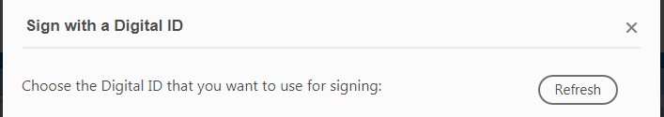
Select Configure new Digital ID
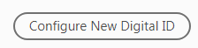
You then have a few options to enable the signature to be created; this can either be by uploading a scanned copy of your signature, by linking to your smartcard or by creating one online through the software.

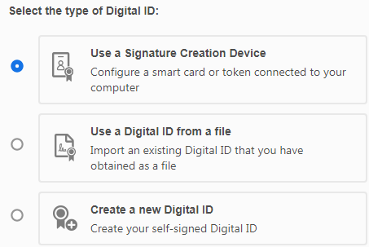

Further Troubleshooting:
- We understand there may be teething issues with the new referral process, please ensure you have read this document and only contact the service if you can’t resolve.
- Please be aware we CANNOT accept new referrals over the phone.
- The PDF requires a software called Javascript to work correctly. There will be a message in a yellow bar at the top of the document if this software is not enabled.
- If you select Options, and then enable Javascript it should then allow you to edit the document.
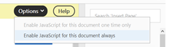
- If this doesn’t work it may be that your organisation has disabled the use of Javascript, in this instance then you will not be able to use the submit function at the bottom of the form.
- If this is the case, you can complete the file and then save/send to Orthotics@nbt.nhs.uk. Alternatively, you can use the word referral form which is still available on our website, but must only be used as a last resort.
https://www.nbt.nhs.uk/bristol-centre-enablement/referral-centre
The new referral method will go-live on Monday 21st March 2022.

