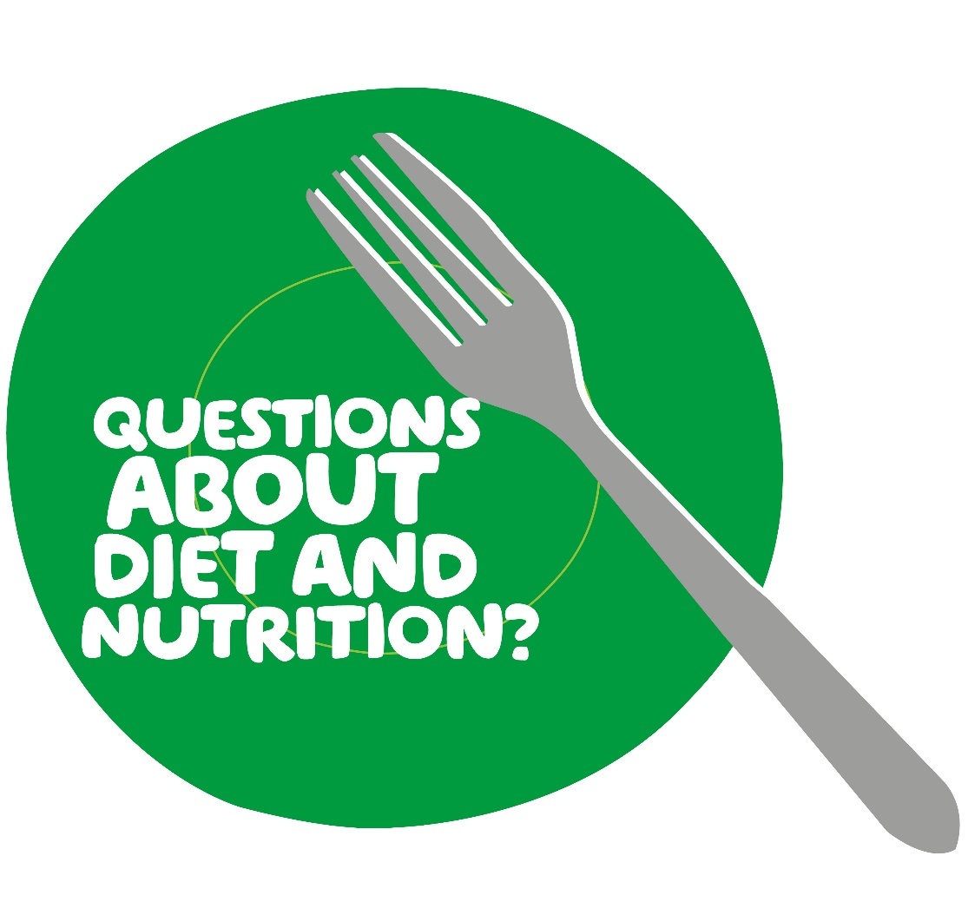
Referral to see a Macmillan Specialist
Dietitian
Options for support: Your needs will be assessed on an individual basis to decide the best way to support you. This could involve a 1:1 consultation, or a video/telephone consultation as appropriate

For more information please contact:
Cancer Dietitians
Tel: 0117 414 5550
Email: MacmillanDietitianReferrals@nbt.nhs.uk
Who do we see: We can provide nutritional advice to anyone living with or beyond a cancer diagnosis. Please refer using this form and send to the email address below. (Referrals for people under other specialist dietetic teams will be discussed)
Common nutritional concerns:
- Eating well to support health for the future
- Managing weight following completion of cancer treatment – acceptance criteria will apply
- Coping with a poor appetite, or unintentional weight loss
- Nutritional support for cancer/treatment related side-effects
- Altered texture diets due to swallowing difficulty
- Making dietary changes as a result of cancers affecting the digestive tract

Professional Referral to see a Dietitian

Full name:
NHS number:
Date of birth:
Address:

Home phone/mobile number:
Email address:
Referrer name and contact number:
Cancer diagnosis:
Treatment intent:
e.g. curative/palliative/surveillance
Cancer Consultant:
Cancer Nurse Specialist:
Please provide a brief summary of any cancer treatment received and approximate dates:
e.g. surgery/chemotherapy /radiotherapy/hormonal therapy /targeted therapy/immunotherapy
Other medical/surgical history:
Please attach patients most recent clinic letter where available - particularly if not under the care of a consultant at NBT
Social information:

Medications:
Please also include nutritional supplements, vitamins/minerals and herbal remedies

Nature of information/advice required:  Please include any specific questions or concerns the patient would like to discuss | Weight: __________ Date: _________ Height: __________
Referral date:
Please note that we may need to contact the patients GP if they are not under a consultant at NBT.
Please ensure that you provide as much information as possible to allow us to prepare fully.

Cancer Dietitians Email: MacmillanDietitianReferrals@nbt.nhs.uk
Nutrition and Dietetics, Kendon House, Tel: 0117 414 5550
Southmead Hospital, Southmead Road,
Bristol, BS10 5NB

