

**Referral to see a Macmillan Specialist**

**Dietitian**

**Options for support:** Your needs will be assessed on an individual basis to decide the best way to support you. This could involve a 1:1 consultation, or a video/telephone consultation as appropriate

**For more information please contact:**

**Cancer Dietitians, Proactive Project**

Tel: 0117 414 5550

Email: proactiveproject@nbt.nhs.uk

**Who do we see:** We can provide nutritional advice to most people living with or beyond a cancer diagnosis. Please refer using this form and send to the email address below.

**We are NOT currently accepting referrals for patients with an upper gastrointestinal malignancy.** Please refer to Remedy for referral to a local dietetic service.

**Common nutritional concerns:**

* Eating well to support health for the future
* Managing weight following completion of cancer treatment – acceptance criteria will apply
* Coping with a poor appetite, or unintentional weight loss
* Nutritional support for cancer/treatment related side-effects
* Altered texture diets due to swallowing difficulty
* Making dietary changes because of cancers affecting the lower gastrointestinal tract

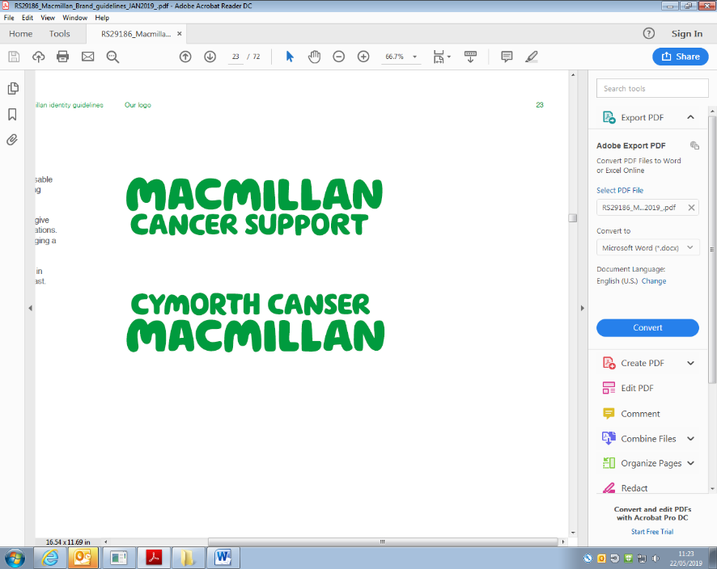**Professional Referral to see a Dietitian**

|  |  |
| --- | --- |
| **Full name:** |  |
| **NHS number:** |  |
| **Date of birth:** |  |
| **Address:** |  |
| **Home phone/mobile number:** |  |
| **Email address:** |  |
| **Referrer name and contact number:** |  |
| **Cancer diagnosis:** |  |
| **Treatment intent:**  e.g. curative/palliative/surveillance/best supportive care |  |
| **Cancer Consultant:** |  |
| **Cancer Nurse Specialist:** |  |
| **Please provide a brief summary of any cancer treatment received and approximate dates:**  e.g. surgery/chemotherapy /radiotherapy/hormonal therapy /targeted therapy/immunotherapy |  |
| **Other medical/surgical history:**  Please attach patients most recent clinic letter where available - particularly if not under the care of a consultant at NBT |  |
| **Social information:** |  |
| **Medications:**  Please also include nutritional supplements, vitamins/minerals and herbal remedies |  |
| **Nature of information/advice required:**  Please include any specific questions or concerns the patient would like to discuss | Weight: __________  Height: __________  Date: _________ |
| **Referral date:** |  |

**Please note that we may need to contact the patients GP if they are not under a consultant at NBT.**

**Please ensure that you provide as much information as possible to allow us to prepare fully.**

**Cancer Dietitians Email:** proactiveproject@nbt.nhs.uk

Proactive Project, Kendon House, **Tel:** 0117 414 5550

Southmead Hospital, Southmead Road,

Bristol, BS10 5NB