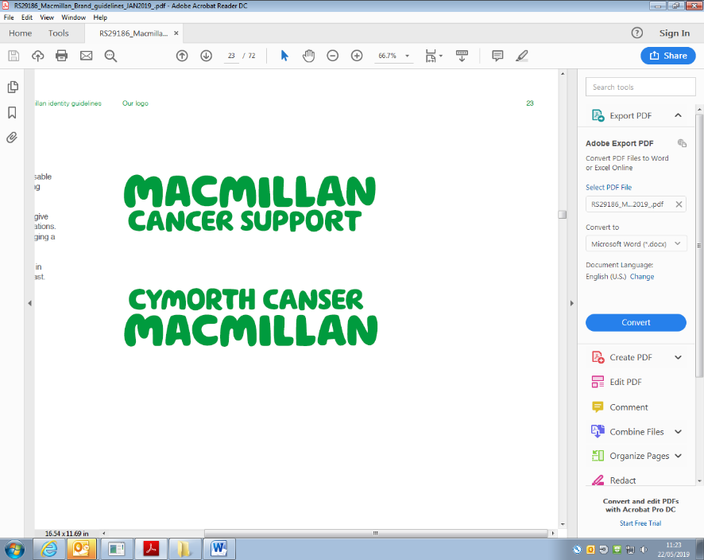

**Self-referral to see a Dietitian**

|  |  |
| --- | --- |
| Full name: |  |
| NHS number: |  |
| Date of birth: |  |
| Address: |  |
| Home phone/mobile number: |  |
| Email address: |  |
| What type of cancer have you been diagnosed with?  e.g. breast/lung/bowel |  |
| Cancer Consultant: |  |
| Cancer Nurse Specialist: |  |
| Please provide a brief summary of any cancer treatment received and approximate dates:  e.g. surgery/chemotherapy /radiotherapy/hormonal therapy /targeted therapy/immunotherapy |  |
| Do you have any other medical conditions which affect your diet or health/wellbeing?  e.g. diabetes/swallowing problems/coeliac disease/  food allergies/mobility problems/depression |  |
| Please provide a list of any medications that you take:  Please also include nutritional supplements, vitamin/minerals and herbal remedies |  |
| Please provide a brief summary of what you would like to discuss with the dietitian:  Please include any specific questions or concerns, to allow us to prepare for your appointment | Weight: ________ Date: ________ Height: ________ |
| How did you hear about us? |  |
| Referral date: |  |

**Please note that we may need to contact your GP if you are not under the care of a consultant at NBT.**

**It is helpful to provide as much information as possible to allow us to prepare for your appointment.**

**Referrals may be sent by post (see address below) or via email - please be aware that our internet server is secure, although yours may not be. Sharing your personal details via email will be at your own discretion.**

**Cancer Dietitians Email:** [MacmillanDietitianReferrals@nbt.nhs.uk](mailto:MacmillanDietitianReferrals@nbt.nhs.uk)

Nutrition and Dietetics, Kendon House, **Tel:** 0117 414 5550

Southmead Hospital, Southmead Road,

Bristol, BS10 5NB



**Self-refer to see a Macmillan Specialist**

**Dietitian**

**Options for support:** Your needs will be assessed on an individual basis to decide the best way to support you. This could involve a 1:1 consultation, or a video/telephone consultation as appropriate

**For more information please contact:**

**Cancer Dietitians**

Tel: 0117 414 5550

Email: MacmillanDietitianReferrals@nbt.nhs.uk

**Who do we see:** We can provide nutritional advice to anyone living with or beyond a cancer diagnosis. Please self-refer or ask your team to make a referral on your behalf. (Referrals for people under other specialist dietetic teams will be discussed)

**Common nutritional concerns:**

* Eating well to support your health for the future
* Managing your weight following completion of cancer treatment – acceptance criteria will apply
* Coping with a poor appetite, or unintentional weight loss
* Nutritional support for cancer/treatment related side-effects
* Altered texture diets due to swallowing difficulty
* Making dietary changes as a result of cancers affecting the digestive tract