
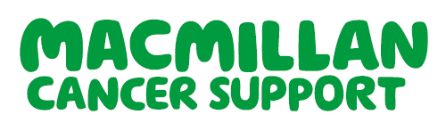
Self-referral to see a Dietitian

Full name:
NHS number:
Date of birth:
Address:

Home phone/mobile number:
Email address:
What type of cancer have you been diagnosed with?
e.g. breast/lung/bowel
Cancer Consultant:
Cancer Nurse Specialist:
Please provide a brief summary of any cancer treatment received and approximate dates:
e.g. surgery/chemotherapy /radiotherapy/hormonal therapy /targeted therapy/immunotherapy
Do you have any other medical conditions which affect your diet or health/wellbeing?
e.g. diabetes/swallowing problems/coeliac disease/
food allergies/mobility problems/depression
Please provide a list of any medications that you take:
Please also include nutritional supplements, vitamin/minerals and herbal remedies
Please provide a brief summary of what you would like to discuss with the dietitian:  Please include any specific questions or concerns, to allow us to prepare for your appointment | Weight: ________ Date: ________ Height: ________
How did you hear about us?
Referral date:
Please note that we may need to contact your GP if you are not under the care of a consultant at NBT.
It is helpful to provide as much information as possible to allow us to prepare for your appointment.
Referrals may be sent by post (see address below) or via email - please be aware that our internet server is secure, although yours may not be. Sharing your personal details via email will be at your own discretion.

Cancer Dietitians Email: proactiveproject@nbt.nhs.uk
Proactive Project, Kendon House, Tel: 0117 414 5550
Southmead Hospital, Southmead Road,
Bristol, BS10 5NB



Referral to see a Macmillan Specialist
Dietitian
Options for support: Your needs will be assessed on an individual basis to decide the best way to support you. This could involve a 1:1 consultation, or a video/telephone consultation as appropriate

For more information please contact:
Cancer Dietitians, Proactive Project
Tel:0117 414 5550
Email: proactiveproject@nbt.nhs.uk
Who do we see: We can provide nutritional advice to most people living with or beyond a cancer diagnosis. Please refer using this form and send to the email address below.
We are NOT currently accepting referrals for patients with an upper gastrointestinal malignancy. Please refer to Remedy for referral to a local dietetic service.
Common nutritional concerns:
Eating well to support health for the future
Managing weight following completion of cancer treatment – acceptance criteria will apply
Coping with a poor appetite, or unintentional weight loss
Nutritional support for cancer/treatment related side-effects
Altered texture diets due to swallowing difficulty
Making dietary changes because of cancers affecting the lower gastrointestinal tract

